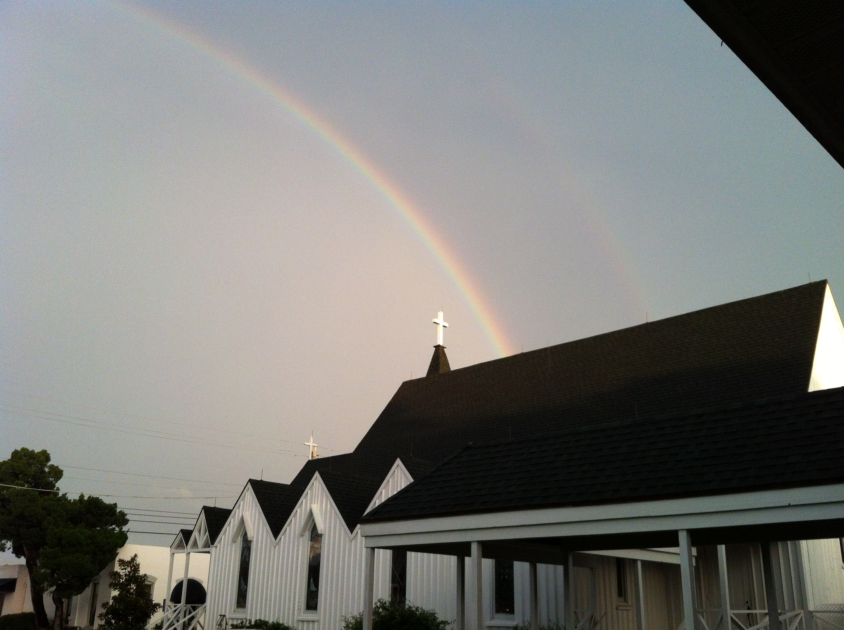
Holy Eucharist
Holy Eucharist Rite II
Christ the King
November 22, 2020
10:00am
10:00am Rite II
November 8, 2020

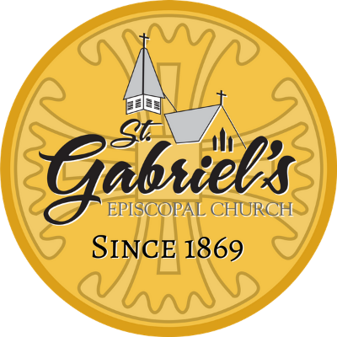

Introit: Choir - “Down to the River to Pray”

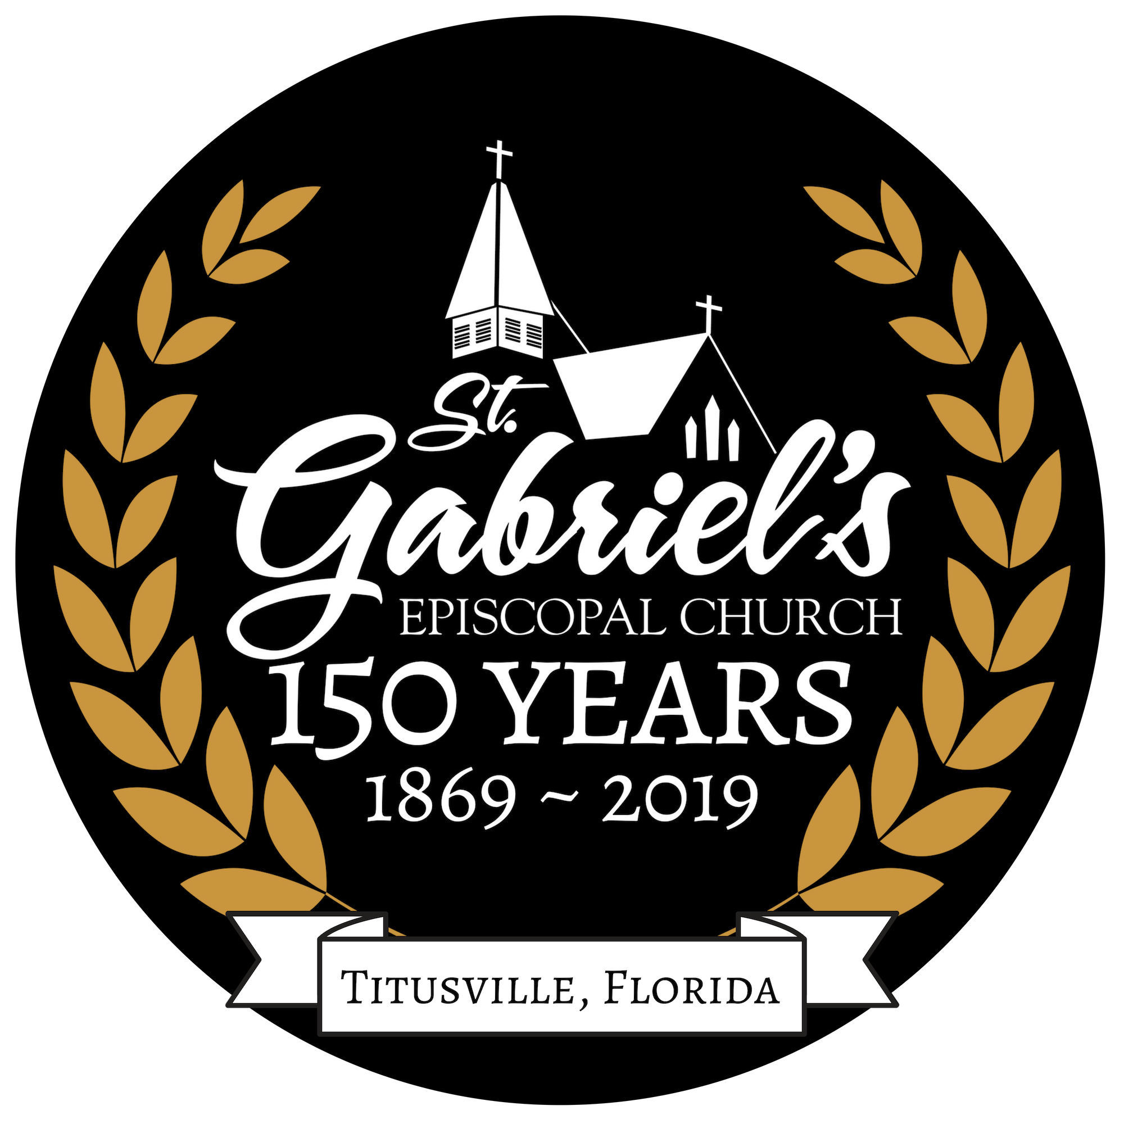

St. Gabriel’s Episcopal Church
414 Pine Street
Titusville, Florida 32796
Office: (321) 267-2545

www.stgabriels.church

Jesus Christ, Head of the Church
The Right Reverend Gregory Brewer, Bishop
The Reverend Dr. Ken Nolen, Associate Priest

WHEN A PASTORAL NEED OCCURS CONTACT:

Father Ken Nolen (831) 235-9827

Office Manager: Karen Fogle, Notary Public
office@stgabriels.church

Senior Warden: Edwin Hill (321) 292-0727
Junior Warden: Ron Rowton (321) 591-7220

Head Verger: Vaughan Kimberling (321) 537-6370
Vergers: Jenni Hill & Ellie Crockett

Bookkeeper: Mary Mulligan
bookkeeper.stgabs@gmail.com

Parish Cook: Rick Purtle (508) 989-2832
Choir Director: David Herzog
Organist: Chris Moore & Andrew Smith

The Forge:
Katie Morrison, Forge Director
godrocks5182@hotmail.com or (321) 412-7706

Introit

Please stand and sing Hymn 544

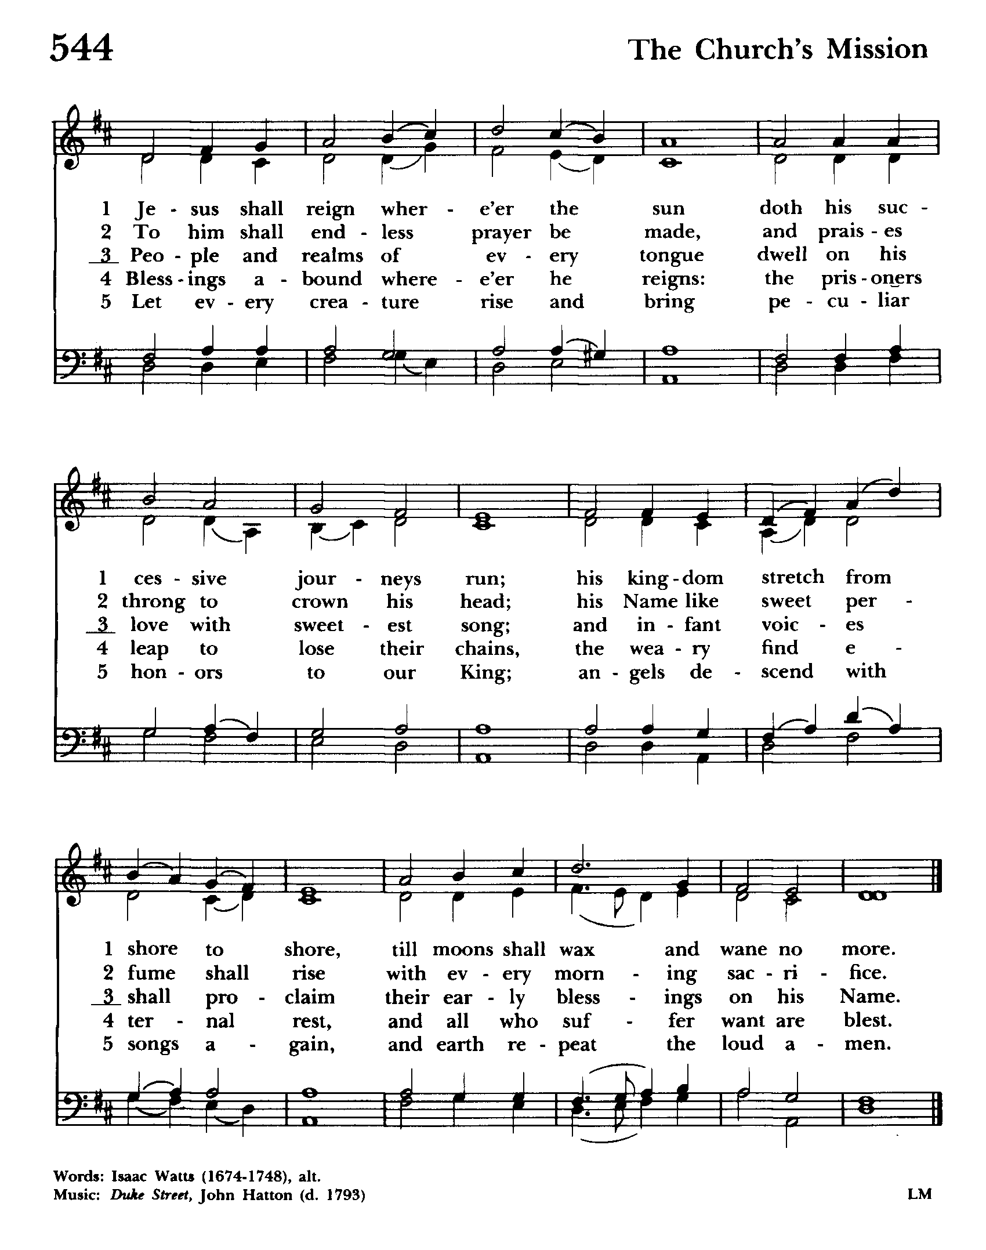

The Last Sunday after Pentecost – Christ the King
Holy Eucharist Rite II
The Word of God

Blessed be God: Father, Son, and Holy Spirit.
And blessed be his kingdom, now and forever. Amen.

Almighty God, to you all hearts are open, all desires known, and from you no secrets are hid: Cleanse the thoughts of our hearts by the inspiration of your Holy Spirit, that we may perfectly love you, and worthily magnify your holy Name; through Christ our Lord. Amen.

Gloria S278

¹ Glory to god in the highest,
and peace to his people on earth.
² Lord God, heavenly King,
almighty God and Father,
we worship you, we give you thanks,
we praise you for your glory.
³ Lord Jesus Christ, only Son of the Father,
Lord God, Lamb of God,
⁴ you take away the sin of the world:
have mercy on us;
⁵ you are seated at the right hand
of the Father:
receive our prayer.
⁶ For you alone are the Holy One,
you alone are the Lord,
⁷ you alone are the Most High,
Jesus Christ, with the Holy Spirit,
in the glory of God the Father, Amen.

The Collect of the Day

The Lord be with you.
And also with you.
Let us pray.
Almighty and everlasting God, whose will it is to restore all things in your well-beloved Son, the King of kings and Lord of lords: Mercifully grant that the peoples of the earth, divided and enslaved by sin, may be freed and brought together under his most gracious rule; who lives and reigns with you and the Holy Spirit, one God, now and forever. Amen.

The Lessons

A Reading from Ezekiel (34:11-16, 20-24)
Thus says the Lord God: I myself will search for my sheep, and will seek them out. As shepherds seek out their flocks when they are among their scattered sheep, so I will seek out my sheep. I will rescue them from all the places to which they have been scattered on a day of clouds and thick darkness. I will bring them out from the peoples and gather them from the countries, and will bring them into their own land; and I will feed them on the mountains of Israel, by the watercourses, and in all the inhabited parts of the land. I will feed them with good pasture, and the mountain heights of Israel shall be their pasture; there they shall lie down in good grazing land, and they shall feed on rich pasture on the mountains of Israel. I myself will be the shepherd of my sheep, and I will make them lie down, says the Lord God. I will seek the lost, and I will bring back the strayed, and I will bind up the injured, and I will strengthen the weak, but the fat and the strong I will destroy. I will feed them with justice. Therefore, thus says the Lord God to them: I myself will judge between the fat sheep and the lean sheep. Because you pushed with flank and shoulder, and butted at all the weak animals with your horns until you scattered them far and wide, I will save my flock, and they shall no longer be ravaged; and I will judge between sheep and sheep. I will set up over them one shepherd, my servant David, and he shall feed them: he shall feed them and be their shepherd. And I, the Lord, will be their God, and my servant David shall be prince among them; I, the Lord, have spoken.
The word of the Lord
Thanks be to God.

Let us sing Psalm 100
¹ Be joyful in the Lord, all you lands; *
serve the Lord with gladness
and come before his presence with a song.
² Know this: The Lord himself is God; *
he himself has made us, and we are his;
we are his people and the sheep of his pasture.
³ Enter his gates with thanksgiving;
go into his courts with praise; *
give thanks to him and call upon his Name.
⁴ For the Lord is good;
his mercy is ever-lasting; *
and his faithfulness endures from age to age.

A reading from Ephesians (1:15-23)

I have heard of your faith in the Lord Jesus and your love toward all the saints, and for this reason I do not cease to give thanks for you as I remember you in my prayers. I pray that the God of our Lord Jesus Christ, the Father of glory, may give you a spirit of wisdom and revelation as you come to know him, so that, with the eyes of your heart enlightened, you may know what is the hope to which he has called you, what are the riches of his glorious inheritance among the saints, and what is the immeasurable greatness of his power for us who believe, according to the working of his great power. God put this power to work in Christ when he raised him from the dead and seated him at his right hand in the heavenly places, far above all rule and authority and power and dominion, and above every name that is named, not only in this age but also in the age to come. And he has put all things under his feet and has made him the head over all things for the church, which is his body, the fullness of him who fills all in all.
The word of the Lord

Thanks be to God
Please stand

Gradual Hymn 555 (Vs. 1)

¹ Lead on, O King eternal,
the day of march has come;
henceforth in fields of conquest
thy tents shall be our home:
through days of preparation
thy grace has made us strong,
and now, O King eternal,
we lift our battle song.

The Holy Gospel of our Lord Jesus Christ according to Matthew (25:31-46)
Glory to you, Lord Christ.

Jesus said, “When the Son of Man comes in his glory, and all the angels with him, then he will sit on the throne of his glory. All the nations will be gathered before him, and he will separate people one from another as a shepherd separates the sheep from the goats, and he will put the sheep at his right hand and the goats at the left. Then the king will say to those at his right hand, ‘Come, you that are blessed by my Father, inherit the kingdom prepared for you from the foundation of the world; for I was hungry and you gave me food, I was thirsty and you gave me something to drink, I was a stranger and you welcomed me, I was naked and you gave me clothing, I was sick and you took care of me, I was in prison and you visited me.’ Then the righteous will answer him, ‘Lord, when was it that we saw you hungry and gave you food, or thirsty and gave you something to drink? And when was it that we saw you a stranger and welcomed you, or naked and gave you clothing? And when was it that we saw you sick or in prison and visited you?’ And the king will answer them, ‘Truly I tell you, just as you did it to one of the least of these who are members of my family, you did it to me.’ Then he will say to those at his left hand, ‘You that are accursed, depart from me into the eternal fire prepared for the devil and his angels; for I was hungry and you gave me no food, I was thirsty and you gave me nothing to drink, I was a stranger and you did not welcome me, naked and you did not give me clothing, sick and in prison and you did not visit me.’ Then they also will answer, ‘Lord, when was it that we saw you hungry or thirsty or a stranger or naked or sick or in prison, and did not take care of you?’ Then he will answer them, ‘Truly I tell you, just as you did not do it to one of the least of these, you did not do it to me.’ And these will go away into eternal punishment, but the righteous into eternal life.”

The Gospel of the Lord.
Praise to you, Lord Christ.

Gradual Hymn 555 (Vs. 3)

³ Lead on, O King eternal:
we follow, not with fears;
for gladness breaks like morning
where'er thy face appears.
Thy cross is lifted o'er us;
we journey in its light:
the crown awaits the conquest;
lead on, O God of might!

The Sermon

The Nicene Creed
We believe in one God,
the Father, the Almighty,
maker of heaven and earth,
of all that is, seen and unseen.
We believe in one Lord, Jesus Christ,
the only Son of God,
eternally begotten of the Father,
God from God, Light from Light,
true God from true God,
begotten, not made,
of one Being with the Father.
Through him all things were made.
For us and for our salvation
he came down from heaven:
by the power of the Holy Spirit
he became incarnate from the Virgin Mary,
and was made man.
For our sake he was crucified under Pontius Pilate;
he suffered death and was buried.
On the third day he rose again
in accordance with the Scriptures;
he ascended into heaven
and is seated at the right hand of the Father.
He will come again in glory to judge the living and the dead,
and his kingdom will have no end.
We believe in the Holy Spirit, the Lord, the giver of life,
who proceeds from the Father and the Son.
With the Father and the Son he is worshiped and glorified.
He has spoken through the Prophets.
We believe in one holy catholic and apostolic Church.
We acknowledge one baptism for the forgiveness of sins.
We look for the resurrection of the dead,
and the life of the world to come. Amen.

The Prayers of the People

Father, we pray for your holy Catholic Church;
That we all may be one.

Grant that every member of the Church may truly and humbly serve you;
That your Name may be glorified by all people.

We pray for all bishops, priests, and deacons;
That they may be faithful ministers of your Word and Sacraments.

We pray for all who govern and hold authority in the nations of the world;
That there may be justice and peace on the earth.

Give us grace to do your will in all that we undertake;
That our works may find favor in your sight.

Have compassion on those who suffer from any grief or trouble; especially Nettie S, Mary Anne Q, Darlene G, Gregg G, Thomas M, Bill S, Ann S, John J and Andrea J.
That they may be delivered from their distress.

Give to the departed eternal rest;
Let light perpetual shine upon them.

We praise you for your saints who have entered into joy;
May we also come to share in your heavenly kingdom.

Let us pray for our own needs and those of others.

Let us confess our sins against God and our neighbor.

Most merciful God,
we confess that we have sinned against you in thought, word, and deed,
by what we have done,
and by what we have left undone.
We have not loved you with our whole heart;
we have not loved our neighbors as ourselves.
We are truly sorry and we humbly repent.
For the sake of your Son Jesus Christ,
have mercy on us and forgive us;
that we may delight in your will,
and walk in your ways,
to the glory of your Name. Amen.

Almighty God have mercy on you, forgive you all your sins through our Lord Jesus Christ, strengthen you in all goodness, and by the power of the Holy Spirit keep you in eternal life. Amen.

The Peace

Please stand

May the peace of the Lord be always with you.
And also with you.

Please greet one another in the name of the lord, without touching.

Announcements

Birthdays
O God, our times are in your hand: Look with favor, we pray, on your servants as they begin another year. Grant that they may grow in wisdom and grace, and strengthen their trust in your goodness all the days of their lives; through Jesus Christ our Lord. Amen.

Anniversaries
O God, you have so consecrated the covenant of marriage that in it is represented the spiritual unity between Christ and his Church: Send therefore your blessing upon these your servants, that they may so love, honor, and cherish each other in faithfulness and patience, in wisdom and true godliness, that their home may be a haven of blessing and peace; through Jesus Christ our Lord, who lives and reigns with you and the Holy Spirit, one God, now and forever. Amen.

Travelers
O God, our heavenly Father, whose glory fills the whole creation, and whose presence we find wherever we go: Preserve those who travel; surround them with your loving care; protect them from every danger; and bring them in safety to their journey's end; through Jesus Christ our Lord. Amen.

Offertory Sentence

Walk in love as Christ loved us, and gave himself to us,
an offering and a sacrifice to God.

Offertory Hymn 435 (Vs. 1,4,5,6)
“At the name of Jesus”
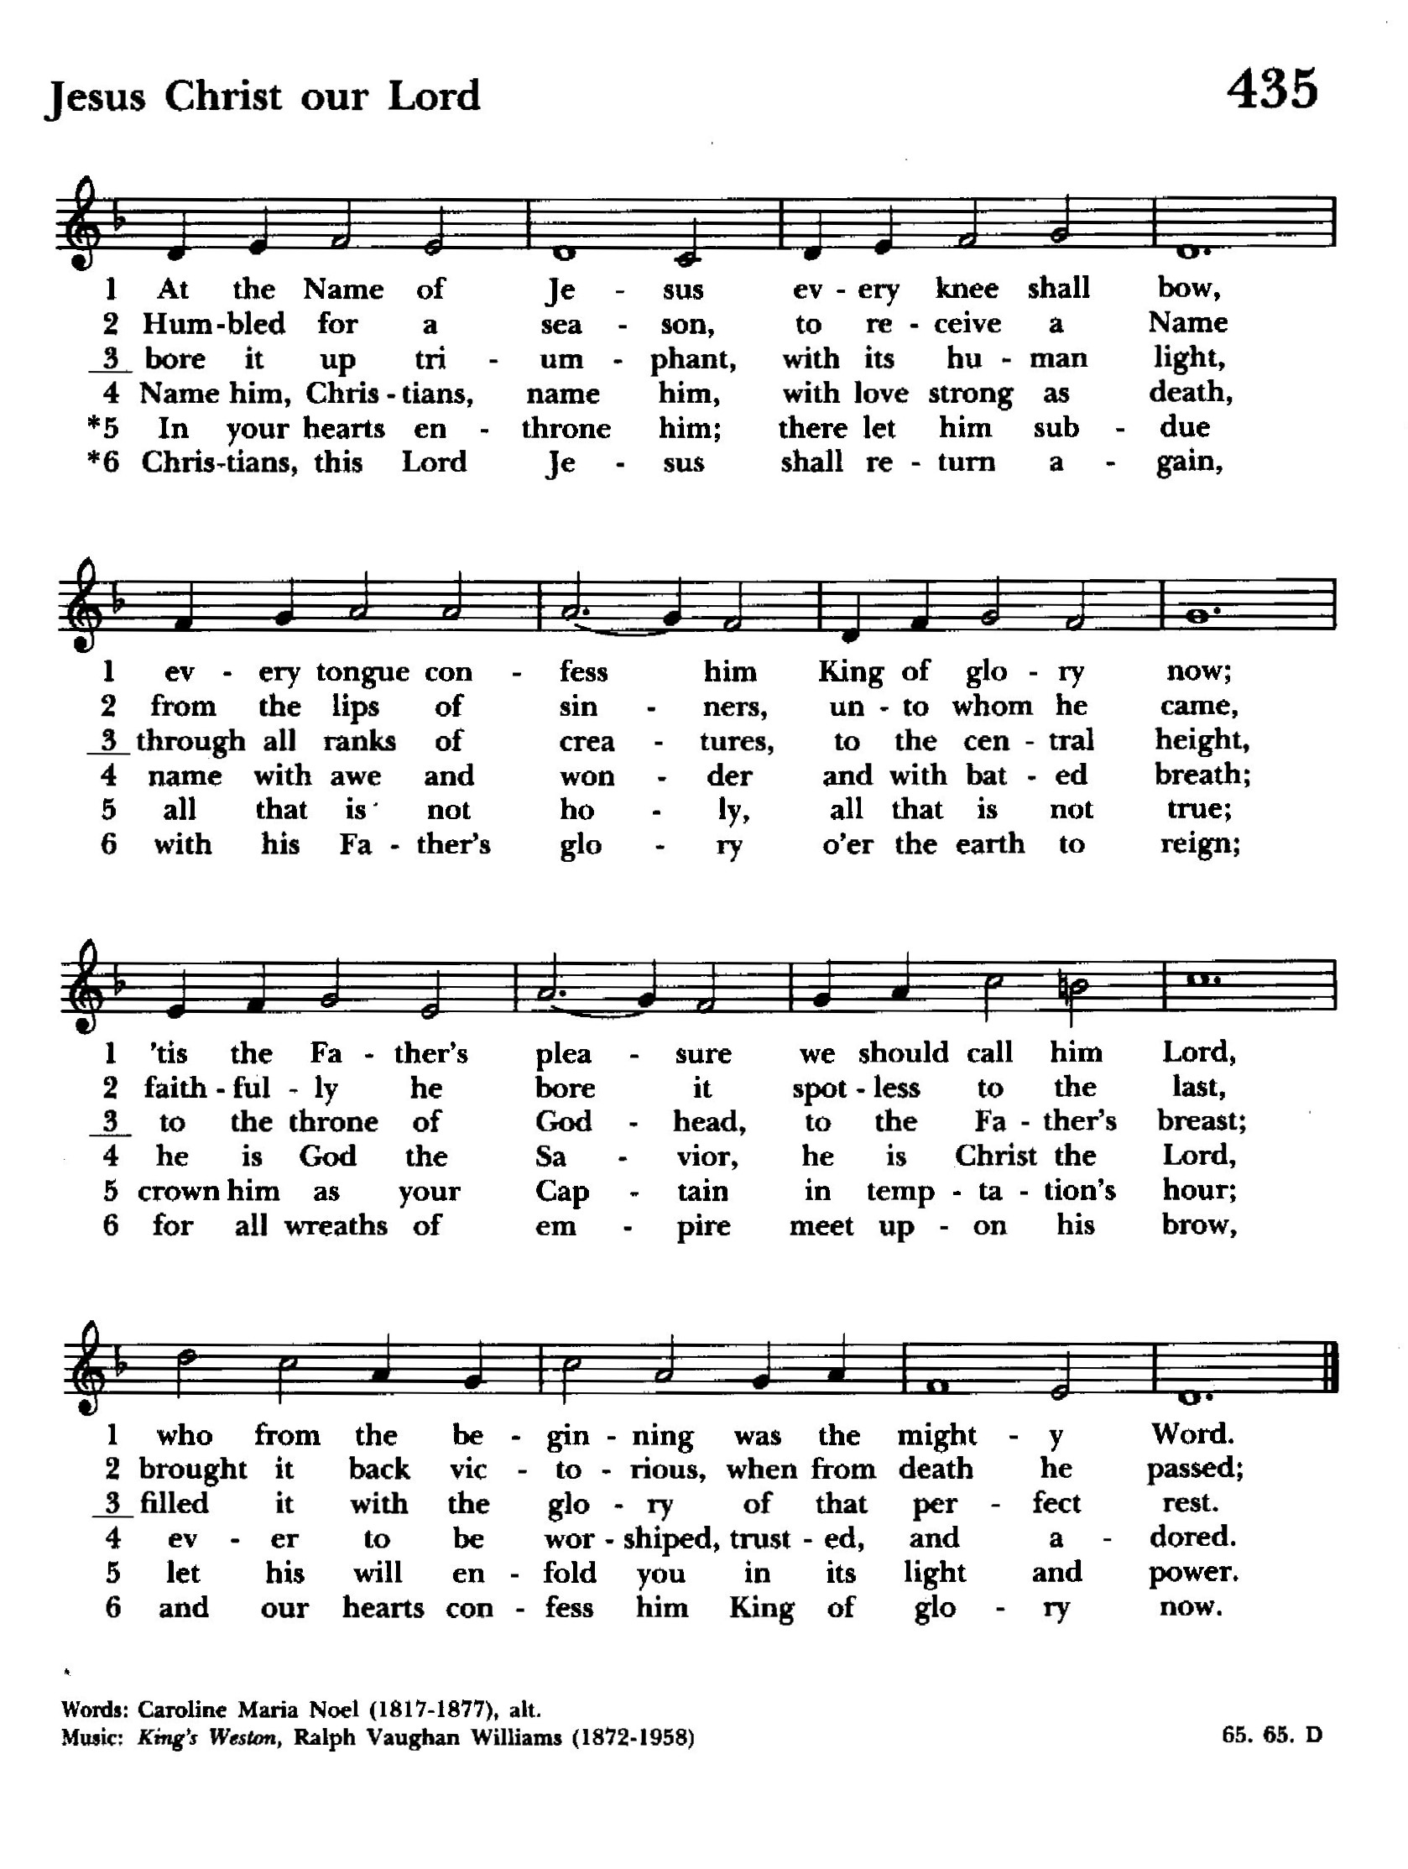

The Great Thanksgiving

Eucharistic Prayer A

The Lord be with you.
And also with you.
Lift up your hearts.
We lift them to the Lord.
Let us give thanks to the Lord our God.
It is right to give him thanks and praise.

It is right, and a good and joyful thing, always and every- where to give thanks to you, Father Almighty, Creator of heaven and earth.

Therefore, we praise you, joining our voices with Angels and Archangels and with all the company of heaven, who forever sing this hymn to proclaim the glory of your Name:

Hymn S-128

Holy, holy, holy Lord, God of power and might,
heaven and earth are full, full of your glory.
Hosanna in the highest.
Blessed is he who comes in the name of the Lord.
Hosanna in the highest.

Holy and gracious Father: In your infinite love you made us for yourself; and, when we had fallen into sin and become subject to evil and death, you, in your mercy, sent Jesus Christ, your only and eternal Son, to share our human nature, to live and die as one of us, to reconcile us to you, the God and Father of all. He stretched out his arms upon the cross, and offered himself in obedience to your will, a perfect sacrifice for the whole world.
On the night he was handed over to suffering and death, our Lord Jesus Christ took bread; and when he had given thanks to you, he broke it, and gave it to his disciples, and said, “Take, eat: This is my Body, which is given for you. Do this for the remembrance of me.”
After supper he took the cup of wine; and when he had given thanks, he gave it to them, and said, “Drink this, all of you: This is my Blood of the new Covenant, which is shed for you and for many for the forgiveness of sins. Whenever you drink it, do this for the remembrance of me.”

Therefore, we proclaim the mystery of faith:

Christ has died.
Christ is risen.
Christ will come again.

We celebrate the memorial of our redemption, O Father, in this sacrifice of praise and thanksgiving. Recalling his death, resurrection, and ascension, we offer you these gifts. Sanctify them by your Holy Spirit to be for your people the Body and Blood of your Son, the holy food and drink of new and unending life in him. Sanctify us also that we may faithfully receive this holy Sacrament, and serve you in unity, constancy, and peace; and at the last day bring us with all your saints
into the joy of your eternal kingdom. All this we ask through your Son Jesus Christ. By him, and with him, and in him, in the unity of the Holy Spirit all honor and glory is yours, Almighty Father, now and forever. Amen.

And now, as our Savior Christ has taught us, we are bold to say,

Our Father, who art in heaven,
hallowed be thy Name,
thy kingdom come,
thy will be done,
on earth as it is in heaven.
Give us this day our daily bread.
And forgive us our trespasses,
as we forgive those who trespass against us.
And lead us not into temptation,
but deliver us from evil.
For thine is the kingdom,
and the power, and the glory,
for ever and ever. Amen.

The Breaking of the Bread

Fraction Anthem S154
Alleluia, alleluia, alleluia.
Christ our Passover is sacrificed for us;
therefore let us keep the feast.
Alleluia, alleluia, alleluia.

The Gifts of God for the People of God.
Take them in remembrance that Christ died for you,
and feed on him in your hearts by faith, with thanksgiving.
For those who are unable to be here today, we offer this prayer…

In union, O Lord,
with your faithful people at every altar of your Church,
where the Holy Eucharist is now being celebrated,
I desire to offer to you praise and thanksgiving.
I remember your death, Lord Christ;
I proclaim your resurrection;
I await your coming in glory.
And since I cannot receive you today in the Sacrament of your Body and Blood, I beseech you to come spiritually into my heart.
Cleanse and strengthen me with your grace, Lord Jesus,
and let me never be separated from you.
May I live in you, and you in me, in this life and in the life to come. Amen.

Post Communion Prayer
Eternal God, heavenly Father,
you have graciously accepted us
as living members of your Son our Savior Jesus Christ,
and you have fed us with spiritual food
in the Sacrament of his Body and Blood.
Send us now into the world in peace,
and grant us strength and courage
to love and serve you
with gladness and singleness of heart;
through Christ our Lord. Amen.

The Blessing
May the peace of God which passes all understanding, keep your hearts and minds in the knowledge and love of God, and his Son Jesus Christ; And the blessing of Almighty God, the Father, the Son and the Holy Spirit be with you now and remain with you always. Amen.

Our closing hymn is number 494 “Crown him with many crowns”

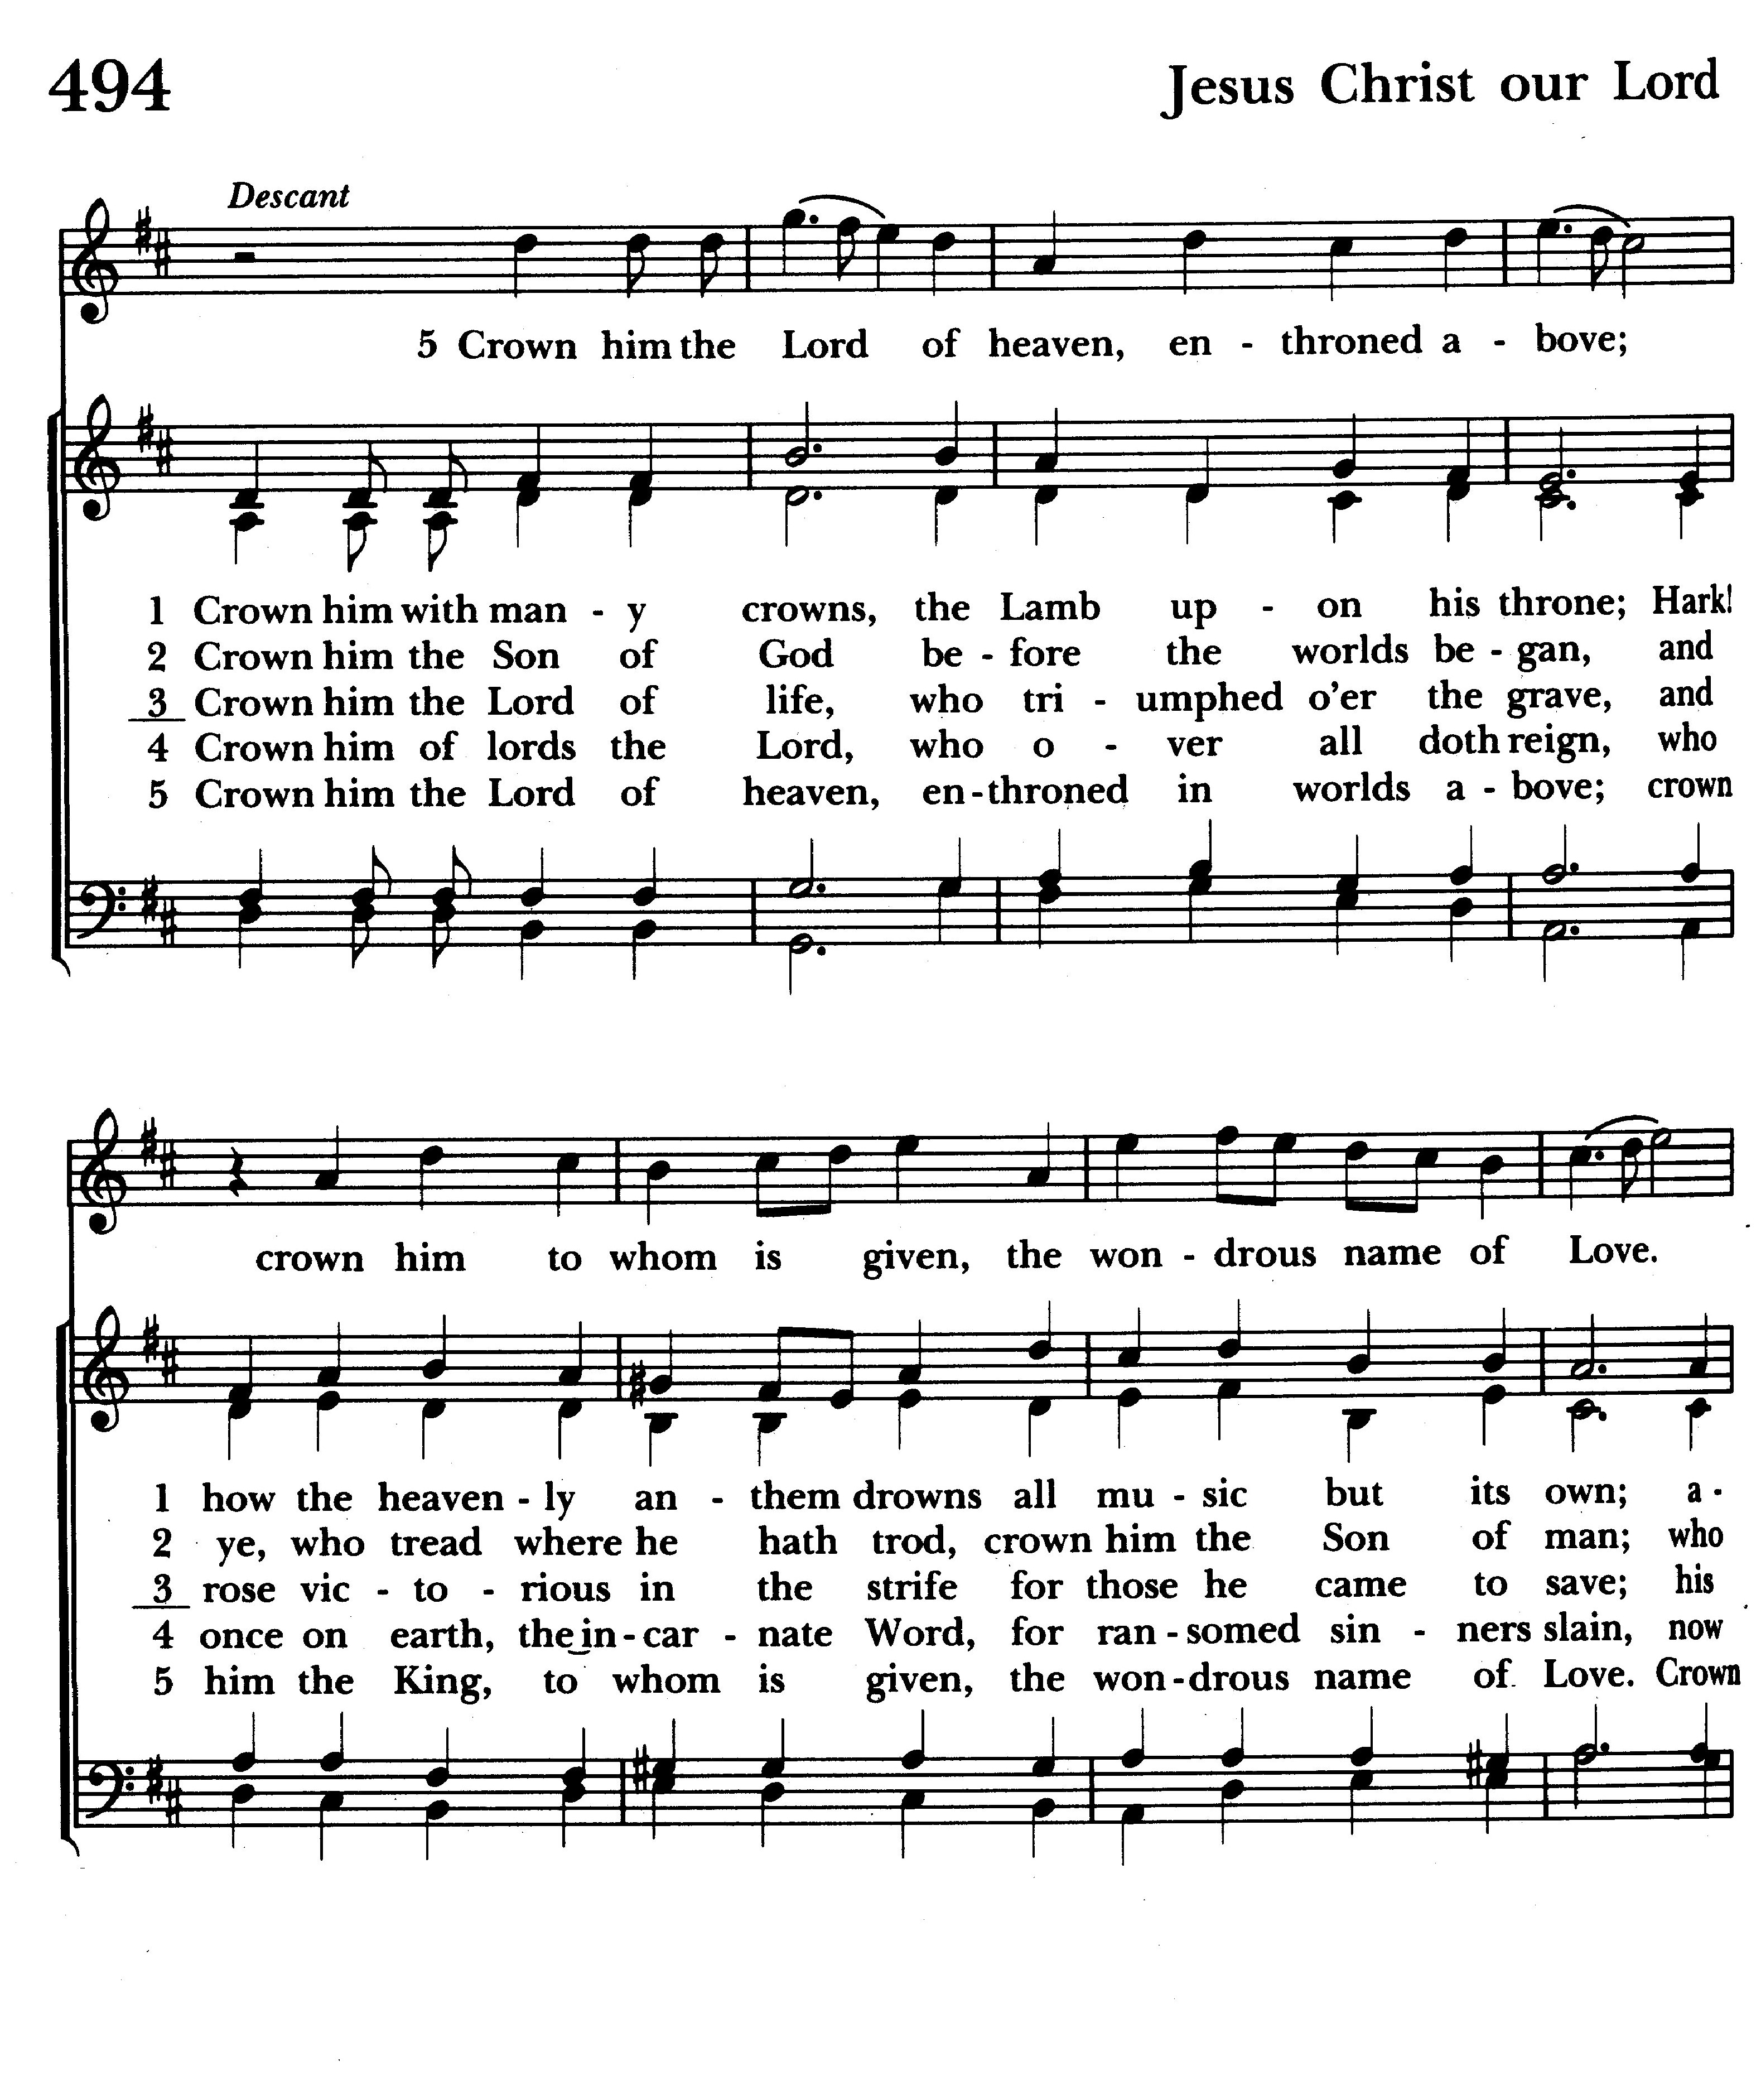

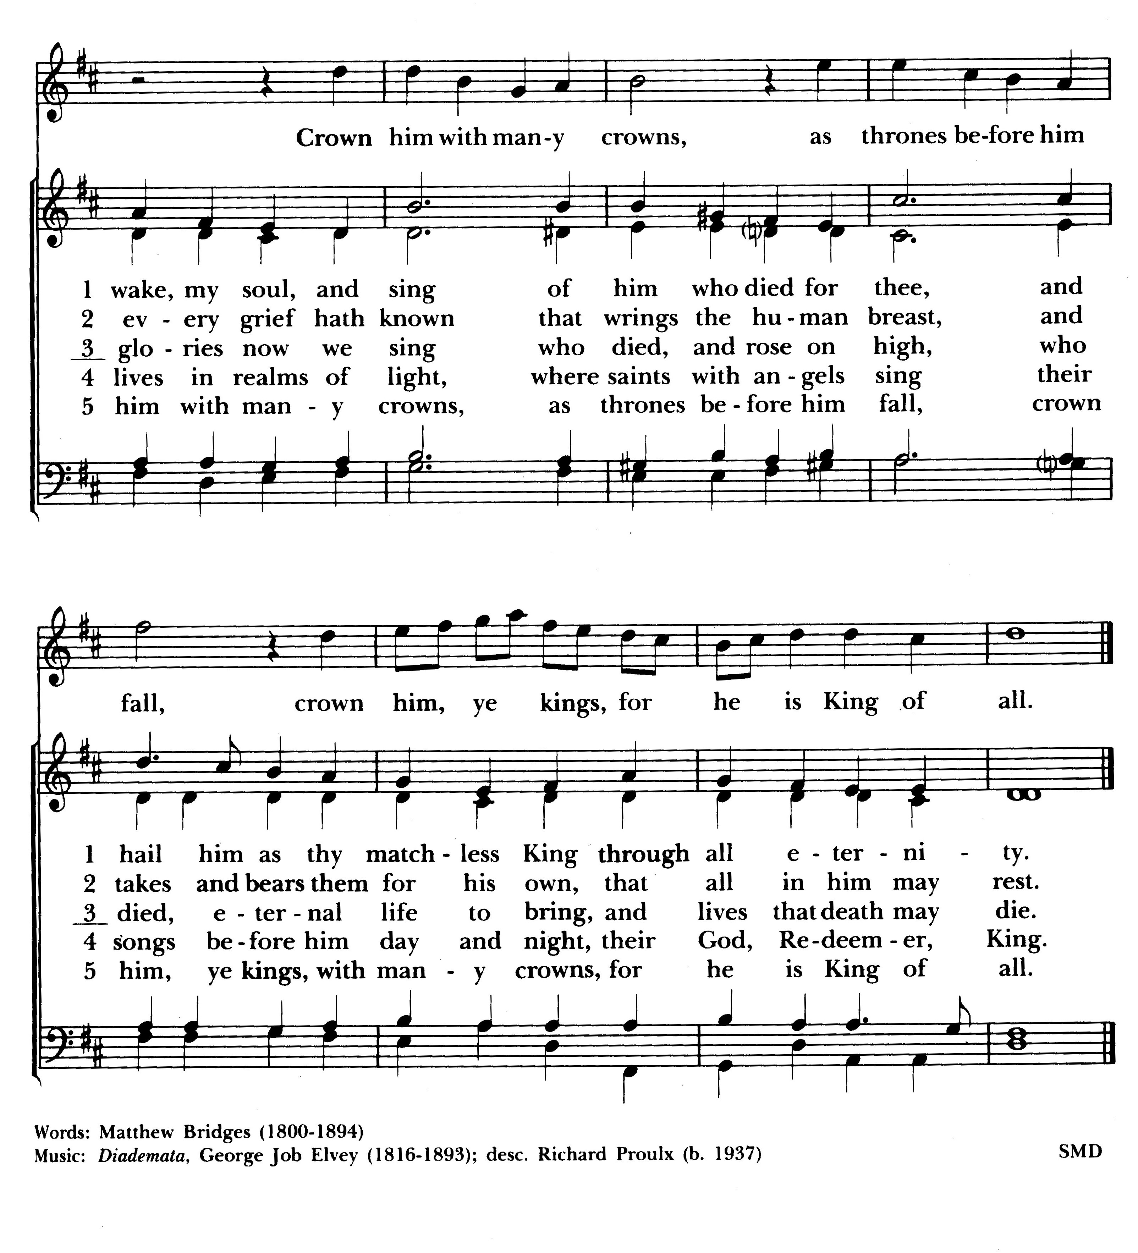

Let us go forth into the world, rejoicing in the power of the Spirit.
Thanks be to God. Alleluia, alleluia.

