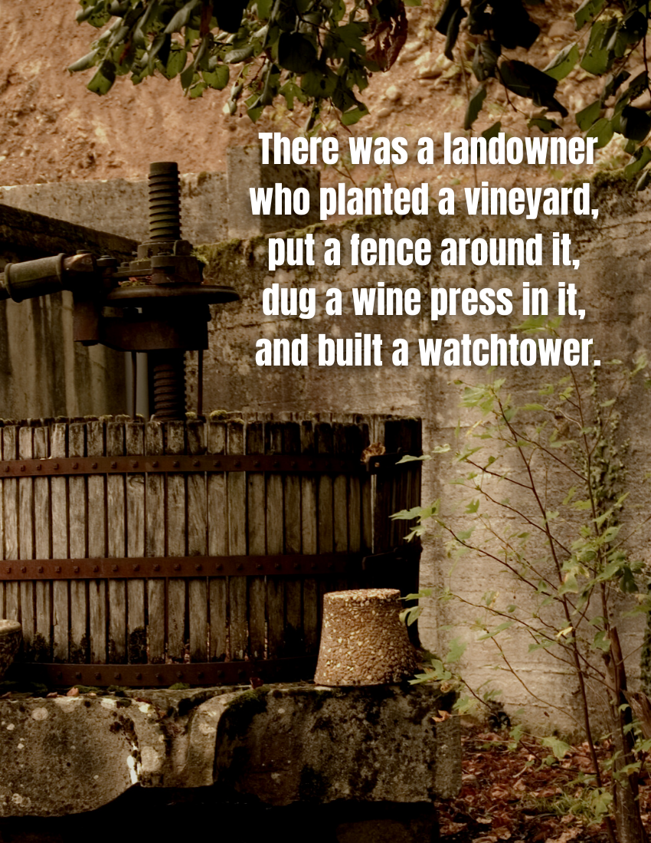

HOLY II | 10:00

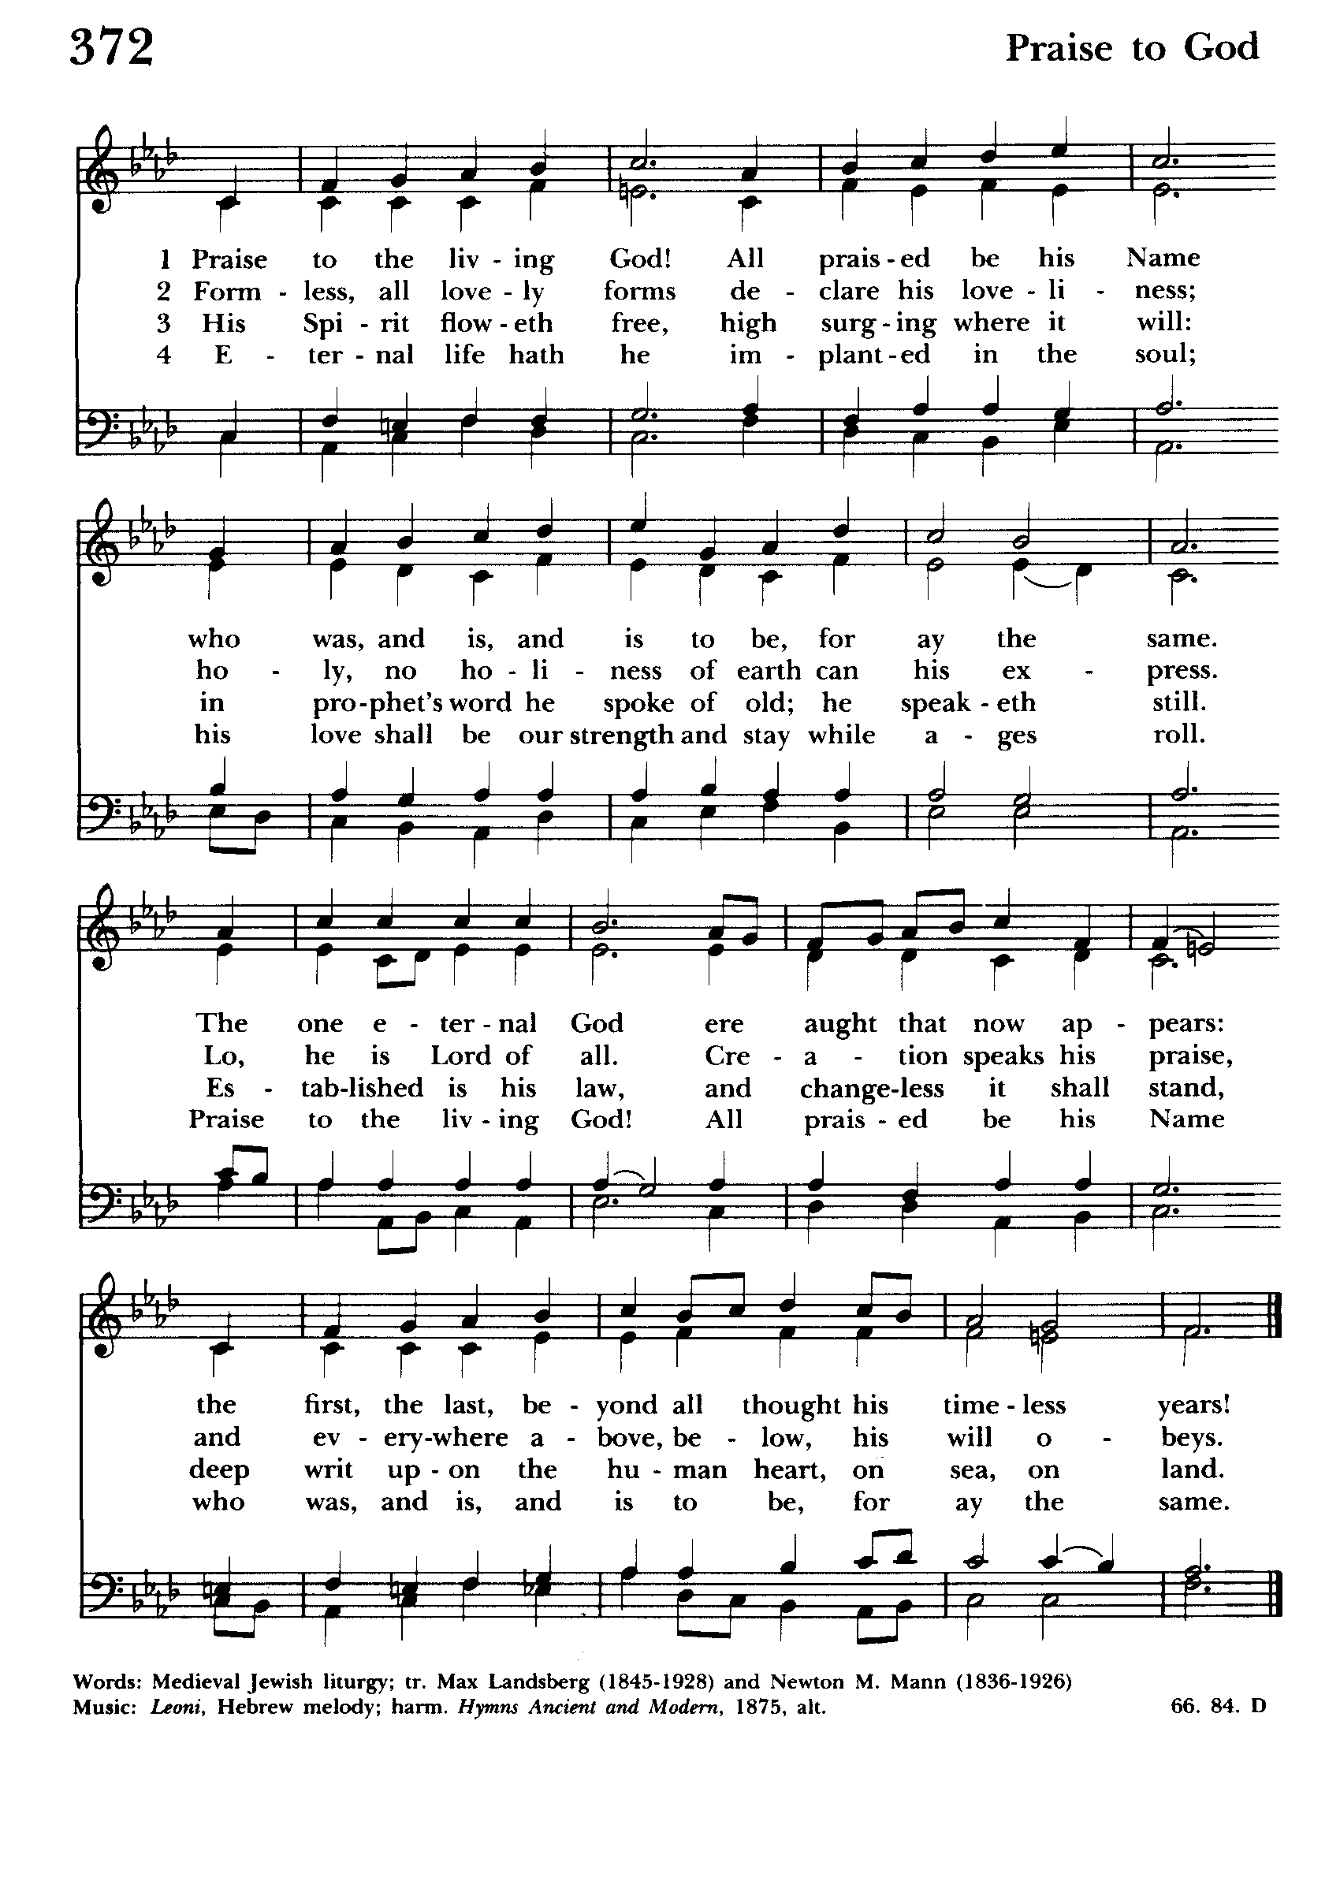

The Sixteenth Sunday after Pentecost
Holy Eucharist Rite II
The Word of God

Blessed be God: Father, Son, and Holy Spirit.
And blessed be his kingdom, now and forever. Amen.

Almighty God, to you all hearts are open, all desires known, and from you no secrets are hid: Cleanse the thoughts of our hearts by the inspiration of your Holy Spirit, that we may perfectly love you, and worthily magnify your holy Name; through Christ our Lord. Amen.

Glory to God in the highest,
and peace to his people on earth.
Lord God, heavenly King, almighty God and Father,
we worship you, we give you thanks, we praise you for your glory.
Lord Jesus Christ, only Son of the Father, Lord God, Lamb of God,
you take away the sin of the world:
have mercy on us;
you are seated at the right hand of the Father:
receive our prayer.
For you alone are the Holy One, you alone are the Lord,
you alone are the Most High,
Jesus Christ,
with the Holy Spirit,
in the glory of God the Father. Amen.

The Collect of the Day

The Lord be with you.
And also with you.

Let us pray.
Almighty and everlasting God, you are always more ready to hear than we to pray, and to give more than we either desire or deserve: Pour upon us the abundance of your mercy, forgiving us those things of which our conscience is afraid, and giving us those good things for which we are not worthy to ask, except through the merits and mediation of Jesus Christ our Savior; who lives and reigns with you and the Holy Spirit, one God, for ever and ever. Amen.

The Lessons

A Reading from Exodus (20:1-4, 7-9, 12-20)

Then God spoke all these words:

I am the Lord your God, who brought you out of the land of Egypt, out of the house of slavery; you shall have no other gods before me.

You shall not make for yourself an idol, whether in the form of anything that is in heaven above, or that is on the earth beneath, or that is in the water under the earth.

You shall not make wrongful use of the name of the Lord your God, for the Lord will not acquit anyone who misuses his name.

Remember the sabbath day, and keep it holy. For six days you shall labor and do all your work.

Honor your father and your mother, so that your days may be long in the land that the Lord your God is giving you.

You shall not murder.

You shall not commit adultery.

You shall not steal.

You shall not bear false witness against your neighbor.

You shall not covet your neighbor’s house; you shall not covet your neighbor’s wife, or male or female slave, or ox, or donkey, or anything that belongs to your neighbor.

When all the people witnessed the thunder and lightning, the sound of the trumpet, and the mountain smoking, they were afraid and trembled and stood at a distance, and said to Moses, “You speak to us, and we will listen; but do not let God speak to us, or we will die.” Moses said to the people, “Do not be afraid; for God has come only to test you and to put the fear of him upon you so that you do not sin.”

The word of the Lord
Thanks be to God.

Psalm 105:1-6, 37-45

¹ The heavens declare the glory of / God, *
and the firmament shows his / handiwork.

² One day tells its tale to an / other, *
and one night imparts knowledge to an / other.

³ Although they have no words or / language, *
and their voices are not / heard,

⁴ Their sound has gone out into all / lands, *
and their message to the ends of the / world.

⁵ In the deep has he set a pavilion for the / sun; *
it comes forth like a bridegroom out of his chamber;
it rejoices like a champion to run its / course.

⁶ It goes forth from the uttermost edge of the heavens
and runs about to the end of it a / gain; *
nothing is hidden from its burning / heat.

⁷ The law of the Lord is perfect and revives the / soul; *
the testimony of the Lord is sure
and gives wisdom to the / innocent.

⁸ The statutes of the Lord are just and rejoice the / heart; *
the commandment of the Lord is clear
and gives light to the / eyes.

⁹ The fear of the Lord is clean and endures for / ever; *
the judgments of the Lord are true
and righteous all to / gether.

¹⁰ More to be desired are they than gold,
more than much fine / gold, *
sweeter far than honey, than honey in the / comb.

¹¹ By them also is your servant en / lightened, *
and in keeping them there is great re / ward.

¹² Who can tell how often he of / fends? *
cleanse me from my secret / faults.

¹³ Above all, keep your servant from presumptuous sins;
let them not get dominion / over me; *
then shall I be whole and sound,
and innocent of a great of / fense.

¹⁴ Let the words of my mouth and the meditation of my
heart be acceptable in your / sight, *
O Lord, my strength and my re / deemer.

A reading from the letter to the Philippians (3:4b-14)
If anyone else has reason to be confident in the flesh, I have more: circumcised on the eighth day, a member of the people of Israel, of the tribe of Benjamin, a Hebrew born of Hebrews; as to the law, a Pharisee; as to zeal, a persecutor of the church; as to righteousness under the law, blameless.
Yet whatever gains I had, these I have come to regard as loss because of Christ. More than that, I regard everything as loss because of the surpassing value of knowing Christ Jesus my Lord. For his sake I have suffered the loss of all things, and I regard them as rubbish, in order that I may gain Christ and be found in him, not having a righteousness of my own that comes from the law, but one that comes through faith in Christ, the righteousness from God based on faith. I want to know Christ and the power of his resurrection and the sharing of his sufferings by becoming like him in his death, if somehow I may attain the resurrection from the dead.
Not that I have already obtained this or have already reached the goal; but I press on to make it my own, because Christ Jesus has made me his own. Beloved, I do not consider that I have made it my own; but this one thing I do: forgetting what lies behind and straining forward to what lies ahead, I press on toward the goal for the prize of the heavenly call of God in Christ Jesus.

The word of the Lord
Thanks be to God

The Holy Gospel of our Lord Jesus Christ according to Matthew (21:33-46)
Glory to you, Lord Christ.

Jesus said, “Listen to another parable. There was a landowner who planted a vineyard, put a fence around it, dug a wine press in it, and built a watchtower. Then he leased it to tenants and went to another country. When the harvest time had come, he sent his slaves to the tenants to collect his produce. But the tenants seized his slaves and beat one, killed another, and stoned another. Again he sent other slaves, more than the first; and they treated them in the same way. Finally, he sent his son to them, saying, ‘They will respect my son.’ But when the tenants saw the son, they said to themselves, ‘This is the heir; come, let us kill him and get his inheritance.” So they seized him, threw him out of the vineyard, and killed him. Now when the owner of the vineyard comes, what will he do to those tenants?” They said to him, “He will put those wretches to a miserable death, and lease the vineyard to other tenants who will give him the produce at the harvest time.”

Jesus said to them, “Have you never read in the scriptures:
‘The stone that the builders rejected
has become the cornerstone;
this was the Lord’s doing,
and it is amazing in our eyes’?

Therefore, I tell you, the kingdom of God will be taken away from you and given to a people that produces the fruits of the kingdom. The one who falls on this stone will be broken to pieces; and it will crush anyone on whom it falls.”

When the chief priests and the Pharisees heard his parables, they realized that he was speaking about them. They wanted to arrest him, but they feared the crowds, because they regarded him as a prophet.

The Gospel of the Lord.
Praise to you, Lord Christ.

The Sermon

The Nicene Creed

We believe in one God,
the Father, the Almighty, maker of heaven and earth, of all that is, seen and unseen.
We believe in one Lord, Jesus Christ, the only Son of God, eternally begotten of the Father, God from God, Light from Light, true God from true God, begotten, not made, of one Being with the Father. Through him all things were made. For us and for our salvation he came down from heaven: by the power of the Holy Spirit he became incarnate from the Virgin Mary, and was made man.
For our sake he was crucified under Pontius Pilate; he suffered death and was buried. On the third day he rose again in accordance with the Scriptures; he ascended into heaven and is seated at the right hand of the Father. He will come again in glory to judge the living and the dead, and his kingdom will have no end.
We believe in the Holy Spirit, the Lord, the giver of life, who proceeds from the Father and the Son. With the Father and the Son he is worshiped and glorified. He has spoken through the Prophets. We believe in one holy catholic and apostolic Church. We acknowledge one baptism for the forgiveness of sins.
We look for the resurrection of the dead, and the life of the world to come.
Amen.

The Prayers of the People

Father, we pray for your holy Catholic Church;
That we all may be one.

Grant that every member of the Church may truly and humbly serve you;
That your Name may be glorified by all people.

We pray for all bishops, priests, and deacons;
That they may be faithful ministers of your Word and Sacraments.

We pray for all who govern and hold authority in the nations of the world;
That there may be justice and peace on the earth.

Give us grace to do your will in all that we undertake;
That our works may find favor in your sight.

Have compassion on those who suffer from any grief or trouble;
That they may be delivered from their distress.

Give to the departed eternal rest;
Let light perpetual shine upon them.

We praise you for your saints who have entered into joy;
May we also come to share in your heavenly kingdom.

Let us pray for our own needs and those of others.

O Lord our God, accept the fervent prayers of your people; in the multitude of your mercies, look with compassion upon us and all who turn to you for help; for you are gracious, O lover of souls, and to you we give glory, Father, Son, and Holy Spirit, now and forever. Amen.

Let us confess our sins against God and our neighbor.

Most merciful God,
we confess that we have sinned against you in thought, word, and deed,
by what we have done,
and by what we have left undone.
We have not loved you with our whole heart;
we have not loved our neighbors as ourselves.
We are truly sorry and we humbly repent.
For the sake of your Son Jesus Christ,
have mercy on us and forgive us;
that we may delight in your will,
and walk in your ways,
to the glory of your Name. Amen.

Almighty God have mercy on you, forgive you all your sins through our Lord Jesus Christ, strengthen you in all goodness, and by the power of the Holy Spirit keep you in eternal life. Amen.

May the peace of the Lord be always with you.
And also with you.

Announcements

Walk in love as Christ loved us, and gave himself to us,
an offering and a sacrifice to God.

The Holy Communion

The Great Thanksgiving
Eucharistic Prayer A

The Lord be with you.
And also with you.
Lift up your hearts.
We lift them to the Lord.
Let us give thanks to the Lord our God.
It is right to give him thanks and praise.

It is right, and a good and joyful thing, always and every- where to give thanks to you, Father Almighty, Creator of heaven and earth. For you are the source of light and life, you made us in your image, and called us to new life in Jesus Christ our Lord. Therefore, we praise you, joining our voices with Angels and Archangels and with all the company of heaven, who forever sing this hymn to proclaim the glory of your Name:
Hymnal S-130

Holy, holy, holy Lord, God of power and might,
Holy, holy, holy Lord, God of power and might,
heaven and earth are full, full of your glory.
Hosanna in the highest. Hosanna in the highest.
Blessed is he who comes in the name of the Lord.
Hosanna in the highest. Hosanna in the highest.

Holy and gracious Father: In your infinite love you made us for yourself; and, when we had fallen into sin and become subject to evil and death, you, in your mercy, sent Jesus Christ, your only and eternal Son, to share our human nature, to live and die as one of us, to reconcile us to you, the God and Father of all. He stretched out his arms upon the cross, and offered himself in obedience to your will, a perfect sacrifice for the whole world.

On the night he was handed over to suffering and death, our Lord Jesus Christ took bread; and when he had given thanks to you, he broke it, and gave it to his disciples, and said, “Take, eat: This is my Body, which is given for you. Do this for the remembrance of me.”
After supper he took the cup of wine; and when he had given thanks, he gave it to them, and said, “Drink this, all of you: This is my Blood of the new Covenant, which is shed for you and for many for the forgiveness of sins. Whenever you drink it, do this for the remembrance of me.”

Therefore, we proclaim the mystery of faith:

Christ has died.
Christ is risen.
Christ will come again.

We celebrate the memorial of our redemption, O Father, in this sacrifice of praise and thanksgiving. Recalling his death, resurrection, and ascension, we offer you these gifts. Sanctify them by your Holy Spirit to be for your people the Body and Blood of your Son, the holy food and drink of new and unending life in him. Sanctify us also that we may faithfully receive this holy Sacrament, and serve you in unity, constancy, and peace; and at the last day bring us with all your saints
into the joy of your eternal kingdom. All this we ask through your Son Jesus Christ. By him, and with him, and in him, in the unity of the Holy Spirit all honor and glory is yours, Almighty Father, now and forever. AMEN.

And now, as our Savior Christ has taught us, we are bold to say,

Our Father, who art in heaven, hallowed be thy Name,
thy kingdom come, thy will be done, on earth as it is in heaven.
Give us this day our daily bread.
And forgive us our trespasses, as we forgive those who trespass against us.
And lead us not into temptation, but deliver us from evil.
For thine is the kingdom, and the power, and the glory, for ever and ever. Amen.
The Breaking of the Bread
Fraction Anthem S-154

Alleluia, alleluia, alleluia.
Christ our Passover is sacrificed for us;
therefore let us keep the feast.
Alleluia, alleluia, alleluia.

The Gifts of God for the People of God.
Take them in remembrance that Christ died for you,
and feed on him in your hearts by faith, with thanksgiving.
For those who are unable to be here today, we offer this prayer…

In union, O Lord,
with your faithful people at every altar of your Church,
where the Holy Eucharist is now being celebrated,
I desire to offer to you praise and thanksgiving.
I remember your death, Lord Christ;
I proclaim your resurrection;
I await your coming in glory.
And since I cannot receive you today in the Sacrament of your Body and Blood, I beseech you to come spiritually into my heart.
Cleanse and strengthen me with your grace, Lord Jesus,
and let me never be separated from you.
May I live in you, and you in me, in this life and in the life to come.
Amen.

Post Communion Prayer

Eternal God, heavenly Father,
you have graciously accepted us
as living members of your Son our Savior Jesus Christ,
and you have fed us with spiritual food
in the Sacrament of his Body and Blood.
Send us now into the world in peace,
and grant us strength and courage
to love and serve you
with gladness and singleness of heart;
through Christ our Lord. Amen.

The Blessing

May the peace of God which passes all understanding, keep your hearts and minds in the knowledge and love of God, and his Son Jesus Christ; And the blessing of Almighty God, the Father, the Son and the Holy Spirit be with you now and remain with you always. Amen.

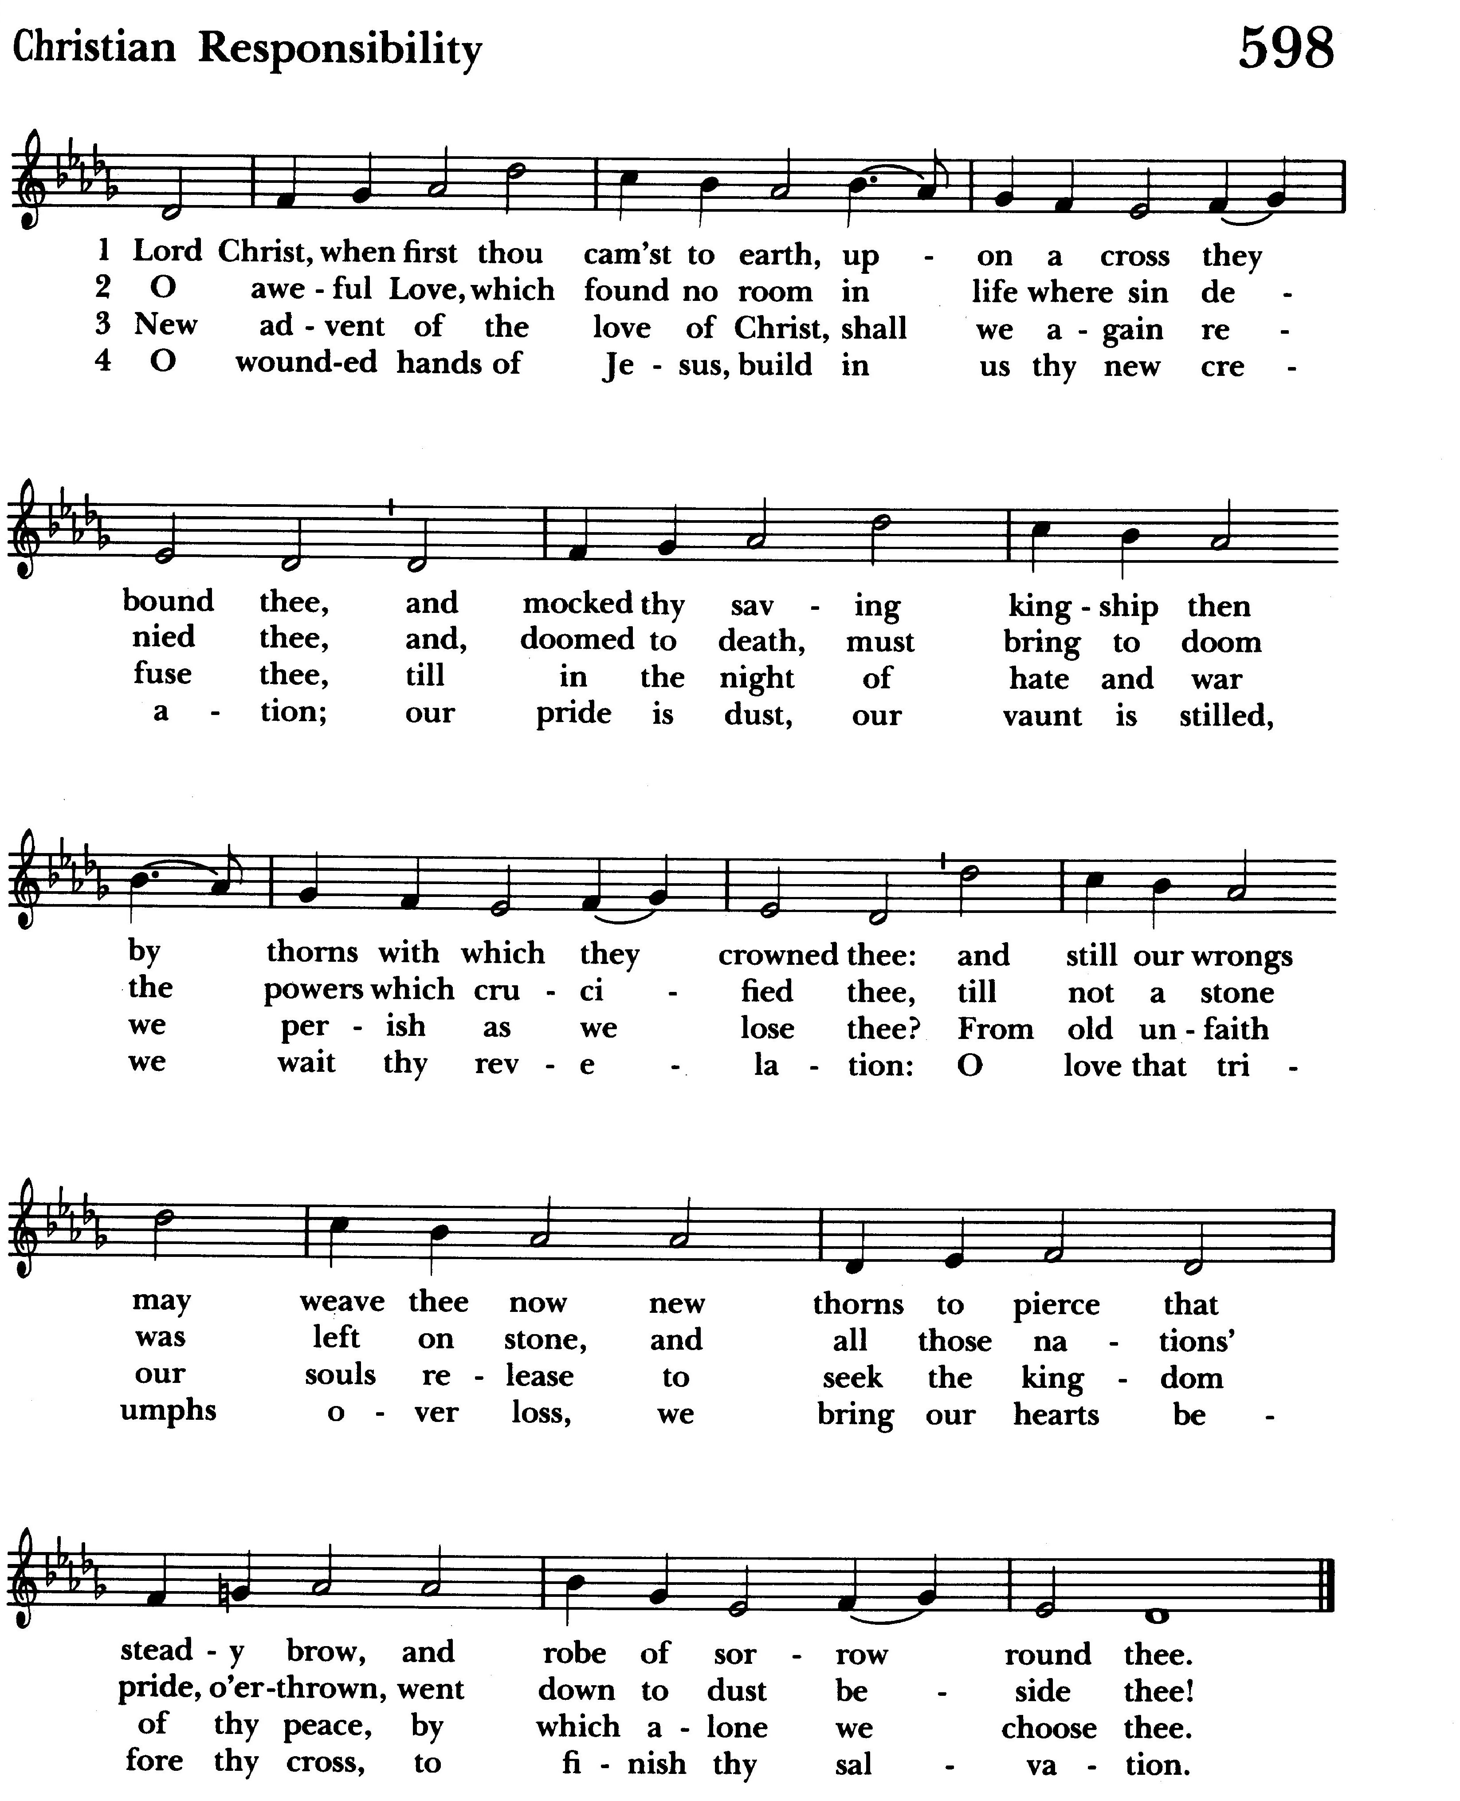
Our closing hymn is number 598 “Lord Christ, when first thou camest to earth”

Let us go forth into the world, rejoicing in the power of the Spirit.
Thanks be to God. Alleluia, alleluia.

