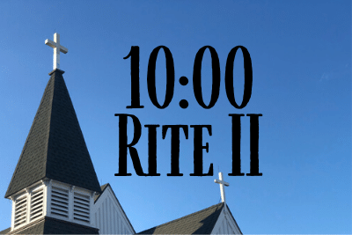
January 24, 2021
3rd Sunday after Epiphany

St. Gabriel’s Episcopal Church
414 Pine St.
Titusville, FL 32796
321-267-2545

Church Leadership
HEAD
Jesus Christ

BISHOP
The Right Rev. Gregory O. Brewer

WORSHIP TEAM
The Rev. Dr. Margaret Callender Davis: Interim Pastor
The Rev. Dr. Ken Nolen: Associate Priest
Vergers: Vaughan Kimberling; Jenni Hill; Ellie Crockett

Andrew Smith: Organist (7:30)
Chris Moore: Organist (10:00)
David Herzog: Choir Director (10:00)

VESTRY
Edwin Hill: Senior Warden (321) 292-0727
Ron Rowton: Junior Warden (321) 591-7220
Lisa Barber * Jim Robey * Barbara Carter * Polly Schuster * Marion Hughes
Vaughan Kimberling, Clerk * Richard Cota, Treasurer * Dr. Al Koller, Vestry Advisor

The Forge - Katie Morrison (321) 412-7706 or godrocks5182@hotmail.com
_______________________________________________________

Sunday Service
10:00 am – Rite II
(live streamed on Facebook)

Office Manager: Karen Fogle – office@stgabriels.church
www.stgabriels.church

Emergency Pastoral Needs:
Pastor Peg Davis (727) 773-5977
Father Ken Nolen (831) 235-9827

Processional / Hymn 533
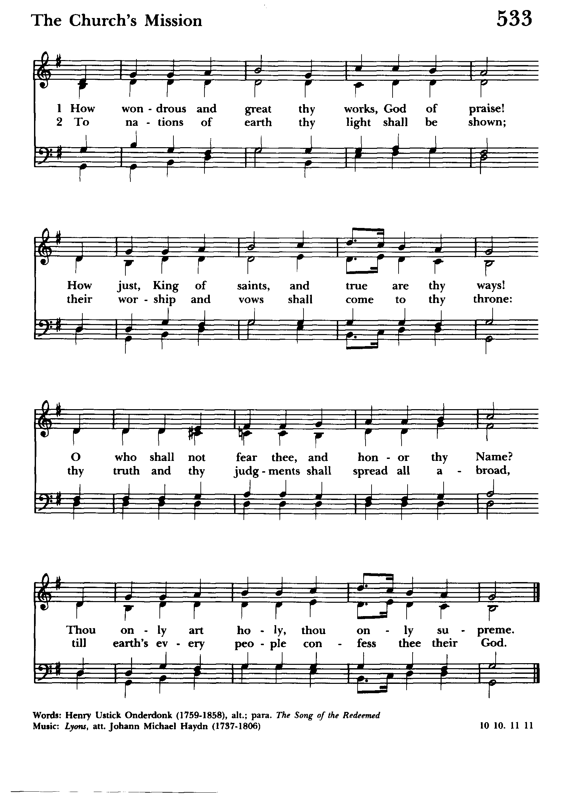

The Word of God

Blessed be God: Father, Son, and Holy Spirit.
And blessed be his kingdom, now and forever. Amen.

Almighty God, to you all hearts are open, all desires known, and from you no secrets are hid: Cleanse the thoughts of our hearts by the inspiration of your Holy Spirit, that we may perfectly love you, and worthily magnify your holy Name; through Christ our Lord. Amen.

Gloria /Hymn S-280
1. Glory to god in the highest,
and peace to his people on earth.
2. Lord God, heavenly King,
almighty God and Father,
we worship you, we give you thanks,
we praise you for your glory.
3. Lord Jesus Christ, only Son of the Father,
Lord God, Lamb of God,
4. you take away the sin of the world:
have mercy on us;
5. you are seated at the right hand
of the Father:
receive our prayer.
6. For you alone are the Holy One,
you alone are the Lord,
7. you alone are the Most High,
Jesus Christ, with the Holy Spirit,
in the glory of God the Father, Amen.

The Collect of the Day

The Lord be with you.
And also with you.
Let us pray.
Give us grace, O Lord, to answer readily the call of our Savior Jesus Christ and proclaim to all people the Good News of his salvation, that we and the whole world may perceive the glory of his marvelous works; who lives and reigns with you and the Holy Spirit, one God, for ever and ever. Amen.

The Lessons

A Reading from Jonah (3:1-5, 10)
The word of the Lord came to Jonah a second time, saying, “Get up, go to Nineveh, that great city, and proclaim to it the message that I tell you.” So Jonah set out and went to Nineveh, according to the word of the Lord. Now Nineveh was an exceedingly large city, a three days' walk across. Jonah began to go into the city, going a day's walk. And he cried out, “Forty days more, and Nineveh shall be overthrown!” And the people of Nineveh believed God; they proclaimed a fast, and everyone, great and small, put on sackcloth.
When God saw what they did, how they turned from their evil ways, God changed his mind about the calamity that he had said he would bring upon them; and he did not do it.
The word of the Lord
Thanks be to God.

Let us sing Psalm 62 (6-14)
6 For God alone my soul in silence waits; *
truly, my hope is in him.
7 He alone is my rock and my sal - vation, *
my stronghold, so that I shall not be shaken.
8 In God is my safety and my honor; *
God is my strong rock and my refuge.
9 Put your trust in him always, O people, *
pour out your hearts before him, for God is our refuge.
10 Those of high degree are but a fleeting breath, *
even those of low estate cannot be trusted.
11 On the scales they are lighter than a breath, *
all of them to - gether.
12 Put no trust in extortion;
in robbery take no empty pride; *
though wealth increase, set not your heart up - on it.
13 God has spoken once, twice have I heard it, *
that power belongs to God.
14 Steadfast love is yours, O Lord, *
for you repay everyone according to his deeds.

A reading from 1 Corinthians (7:29-31)
I mean, brothers and sisters, the appointed time has grown short; from now on, let even those who have wives be as though they had none, and those who mourn as though they were not mourning, and those who rejoice as though they were not rejoicing, and those who buy as though they had no possessions, and those who deal with the world as though they had no dealings with it. For the present form of this world is passing away.
The word of the Lord
Thanks be to God

The Gradual / Hymn 661
(Before The Gospel Verse 1
After The Gospel Verses 2

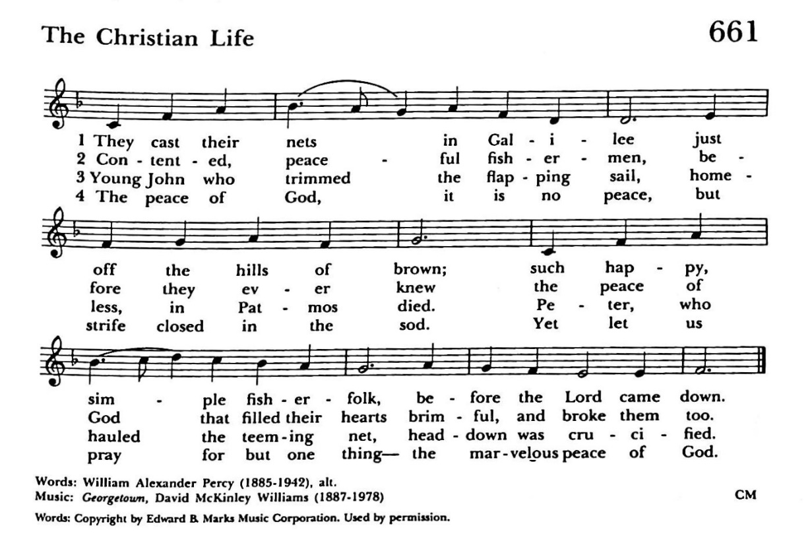

The Holy Gospel of our Lord Jesus Christ according to
Mark (1:14-20)
Glory to you, Lord Christ.
After John was arrested, Jesus came to Galilee, proclaiming the good news of God, and saying, “The time is fulfilled, and the kingdom of God has come near; repent, and believe in the good news.”
As Jesus passed along the Sea of Galilee, he saw Simon and his brother Andrew casting a net into the sea—for they were fishermen. And Jesus said to them, “Follow me and I will make you fish for people.” And immediately they left their nets and followed him. As he went a little farther, he saw James son of Zebedee and his brother John, who were in their boat mending the nets. Immediately he called them; and they left their father Zebedee in the boat with the hired men, and followed him.
The Gospel of the Lord.
Praise to you, Lord Christ.

The Sermon

The Nicene Creed

We believe in one God, the Father, the Almighty,
maker of heaven and earth,
of all that is, seen and unseen.

We believe in one Lord, Jesus Christ,
the only Son of God,
eternally begotten of the Father,
God from God, Light from Light,
true God from true God,
begotten, not made,
of one Being with the Father.
Through him all things were made.
For us and for our salvation
he came down from heaven:
by the power of the Holy Spirit
he became incarnate from the Virgin Mary,
and was made man.
For our sake he was crucified under Pontius Pilate;
he suffered death and was buried.
On the third day he rose again
in accordance with the Scriptures;
he ascended into heaven
and is seated at the right hand of the Father.
He will come again in glory to judge the living and the dead,
and his kingdom will have no end.

We believe in the Holy Spirit, the Lord, the giver of life,
who proceeds from the Father and the Son.
With the Father and the Son
he is worshiped and glorified.
He has spoken through the Prophets.
We believe in one holy catholic and apostolic Church.
We acknowledge one baptism for the forgiveness of sins.
We look for the resurrection of the dead,
and the life of the world to come. Amen.
Prayers of the People – Form I

With all our heart and with all our mind, let us pray to the Lord,
saying "Lord, have mercy."

For the peace from above, for the loving-kindness of God,
and for the salvation of our souls,
let us pray to the Lord.
Lord, have mercy.

For the peace of the world, for the welfare of
the Holy Church of God, and for the unity of all peoples,
let us pray to the Lord.
Lord, have mercy.

For our Bishop, and for all the clergy and people,
let us pray to the Lord.
Lord, have mercy.

For our President, for the leaders of the nations,
and for all in authority.
let us pray to the Lord.
Lord, have mercy.

For the city of Titusville, for every city and community,
and for those who live in them,
let us pray to the Lord.
Lord, have mercy.

For seasonable weather, and for an abundance
of the fruits of the earth,
let us pray to the Lord.
Lord, have mercy.

For the good earth which God has given us, and for the wisdom
and will to conserve it,
let us pray to the Lord.
Lord, have mercy.

For those who travel on land, on water, or in the air
[or through outer space],
let us pray to the Lord.
Lord, have mercy.

For the aged and infirm, for the widowed and orphans, and for the sick and the suffering, especially Bill D, Brian M, Elaine F, Tony K, Maggie L,
let us pray to the Lord.
Lord, have mercy.

For the poor and the oppressed, for the unemployed and the destitute, for prisoners and captives, and for all who remember and care for them,
let us pray to the Lord.
Lord, have mercy.

For all who have died in the hope of the resurrection,
and for all the departed,
let us pray to the Lord.
Lord, have mercy.

For deliverance from all danger, violence, oppression,
and degradation,
let us pray to the Lord.
Lord, have mercy.

For the absolution and remission of our sins and offenses,
let us pray to the Lord.
Lord, have mercy.

That we may end our lives in faith and hope, without suffering
and without reproach,
let us pray to the Lord.
Lord, have mercy.

Defend us, deliver us, and in thy compassion protect us, O Lord,
by thy grace.
Lord, have mercy.

In the communion of St. Gabriel’s, the Blessed Virgin Mother and of all the saints, let us commend ourselves, and one another, and all our life,
to Christ our God.
To thee, O Lord our God.
Silence.
Today, we pray for the parishes of Church of the Blessed Redeemer, Palm Bay and Grace Church, Port Orange.

We pray for all refuges in our communities and in the world.
Please join me for a special prayer during this pandemic.
Lord Jesus Christ, our Divine Physician, we ask you to guard and protect us from COVID-19 and from all serious illness. For all that have died from it, have mercy; for those who are ill now, bring healing. For those who are searching for a remedy, enlighten them; for medical caregivers helping the sick, strengthen and shield them. By your grace, may you remove the evil of disease, and replace it with consolation and hope. We abandon ourselves to your infinite love and mercy. Amen.
Silence
For yours is the majesty, O Father, Son, and Holy Spirit; yours is the kingdom and the power and the glory, now and for ever. Amen.

The Confession of Sin

Let us confess our sins against God and our neighbors.
(Please kneel or sit as you are able).

Most merciful God,
we confess that we have sinned against you
in thought, word, and deed,
by what we have done,
and by what we have left undone.
We have not loved you with our whole heart;
we have not loved our neighbors as ourselves.
We are truly sorry and we humbly repent.
For the sake of your Son Jesus Christ,
have mercy on us and forgive us;
that we may delight in your will,
and walk in your ways,
to the glory of your Name. Amen.

The peace of the Lord be always with you.
And also with you.

Announcements & Special Blessings

Birthdays

O God, our times are in your hand: Look with favor, we pray, on your servants as they begin another year. Grant that they may grow in wisdom and grace, and strengthen their trust in your goodness all the days of their lives; through Jesus Christ our Lord. Amen.

Anniversaries

O God, you have so consecrated the covenant of marriage that in it is represented the spiritual unity between Christ and his Church: Send therefore your blessing upon these your servants, that they may so love, honor, and cherish each other in faithfulness and patience, in wisdom and true godliness, that their home may be a haven of blessing and peace; through Jesus Christ our Lord, who lives and reigns with you and the Holy Spirit, one God, now and for ever. Amen.

Travelers

O God, our heavenly Father, whose glory fills the whole creation, and whose presence we find wherever we go: Preserve those who travel; surround them with your loving care; protect them from every danger; and bring them in safety to their journey's end; through Jesus Christ our Lord. Amen.

The Holy Communion

Offertory Sentence

Walk in love as Christ loved us, and gave himself to us,
an offering and a sacrifice to God.

The Offertory Hymn
(Choir will sing)

The Great Thanksgiving

Eucharistic Prayer A

The Lord be with you
And also with you

Lift up your hearts
We lift them to the Lord

Let us give thanks to the Lord our God
It is right to give him thanks and praise

It is right, and a good and joyful thing, always and everywhere to give thanks to you, Father Almighty, Creator of heaven and earth.

Because in the mystery of the Word made flesh, you have caused a new light to shine in our hearts, to give the knowledge of your glory in the face of your son Jesus Christ our Lord.

Therefore, we praise you, joining our voices with Angels and Archangels and with all the company of heaven, who for ever sing this hymn to proclaim the glory of your Name:

Sanctus S-130

Holy, holy, holy Lord, God of power and might,
heaven and earth are full of your glory.
Hosanna in the highest
Blessed is he who comes in the name of the Lord.
Hosanna in the Highest

We give thanks to you, O God, for the goodness and love which you have made known to us in creation; in the calling of Israel to be your people; in your Word spoken through the prophets; and above all in the Word made flesh, Jesus, your Son. For in these last days you sent him to be incarnate from the Virgin Mary, to be the Savior and Redeemer of the world. In him, you have delivered us from evil, and made us worthy to stand before you. In him, you have brought us out of error into truth, out of sin into righteousness, out of death into life.
On the night before he died for us, our Lord Jesus Christ took bread; and when he had given thanks to you, he broke it, and gave it to his disciples, and said, "Take, eat: This is my Body, which is given for you. Do this for the remembrance of me."
After supper he took the cup of wine; and when he had given thanks, he gave it to them, and said, "Drink this, all of you: This is my Blood of the new Covenant, which is shed for you and for many for the forgiveness of sins. Whenever you drink it, do this for the remembrance of me."
Therefore, according to his command, O Father,
Celebrant and People
We remember his death,
We proclaim his resurrection,
We await his coming in glory;
And we offer our sacrifice of praise and thanksgiving to you, O Lord of all; presenting to you, from your creation, this bread and this wine.
We pray you, gracious God, to send your Holy Spirit upon these gifts that they may be the Sacrament of the Body of Christ and his Blood of the new Covenant. Unite us to your Son in his sacrifice, that we may be acceptable through him, being sanctified by the Holy Spirit. In the fullness of time, put all things in subjection under your Christ, and bring us to that heavenly country where, with St. Gabriel and all your saints, we may enter the everlasting heritage of your sons and daughters; through Jesus Christ our Lord, the firstborn of all creation, the head of the Church, and the author of our salvation.
By him, and with him, and in him, in the unity of the Holy Spirit all honor and glory is yours, Almighty Father, now and for ever. Amen.

And now, as our Savior
Christ has taught us,
we are bold to say,

Our Father, who art in heaven,
hallowed be Thy name,
Thy kingdom come,
Thy will be done,
on earth as it is in heaven.
Give us this day our daily bread.
And forgive us our trespasses,
as we forgive those
who trespass against us.
And lead us not into temptation,
but deliver us from evil.
For thine is the kingdom,
and the power, and the glory,
for ever and ever. Amen

The Breaking of the Bread

Alleluia. Christ our Passover is sacrificed for us;
Therefore, let us keep the feast. Alleluia.

Anthem S-164
Jesus, Lamb of God:
have mercy on us.
Jesus, bearer of our sins:
have mercy on us.
Jesus, redeemer of the world:
give us your peace.

The gifts of God for the people of God.
Take them in remembrance that Christ died for you,
and feed on him in your hearts by faith, with thanksgiving.

Prayer of Intention
(for those viewing on-line)

In union, O Lord,
with your faithful people at every altar of your Church,
where the Holy Eucharist is now being celebrated,
I desire to offer to you praise and thanksgiving.
I remember your death, Lord Christ;
I proclaim your resurrection;
I await your coming in glory.
And since I cannot receive you today in the Sacrament
of your Body and Blood,
I beseech you to come spiritually into my heart.
Cleanse and strengthen me with your grace, Lord Jesus,
and let me never be separated from you.
May I live in you, and you in me, in this life and in the life to come.
Amen.
(distribution of communion)

Post Communion Prayer

Almighty and everliving God, we thank you for feeding us with the spiritual food of the most precious Body and Blood of your Son our Savior Jesus Christ; and for assuring us in these holy mysteries that we are living members of the Body of your Son, and heirs of your eternal kingdom. And now, Father, send us out to do the work you have given us to do, to love and serve you as faithful witnesses of Christ our Lord. To him, to you, and to the Holy Spirit, be honor and glory, now and for ever. Amen.

The Blessing
Almighty God have mercy on you, forgive you all your sins through our Lord Jesus Christ, strengthen you in all goodness, and by the power of the Holy Spirit keep you in eternal life. Amen.

The Procession into the World / Hymn 530

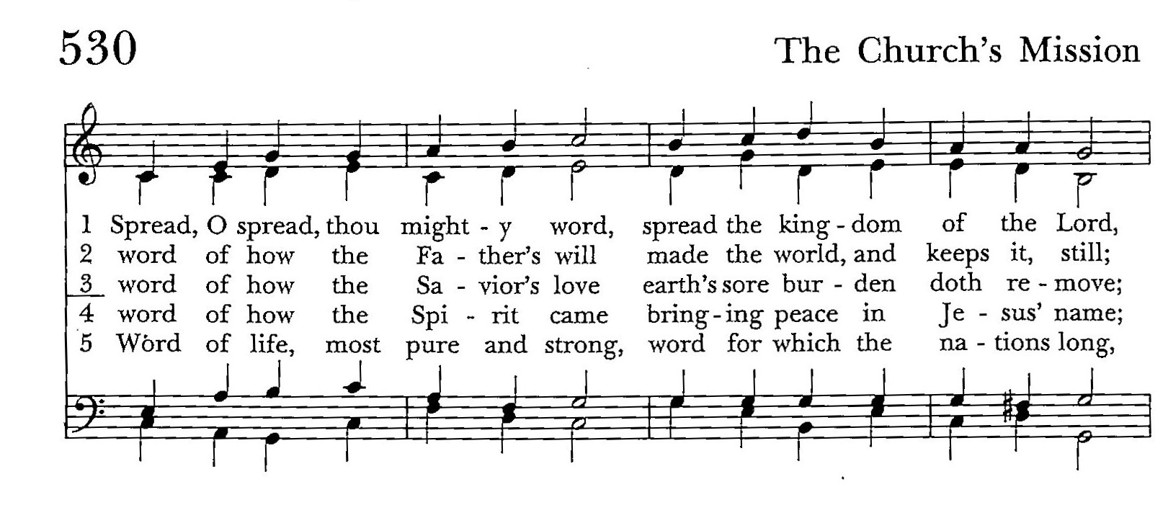

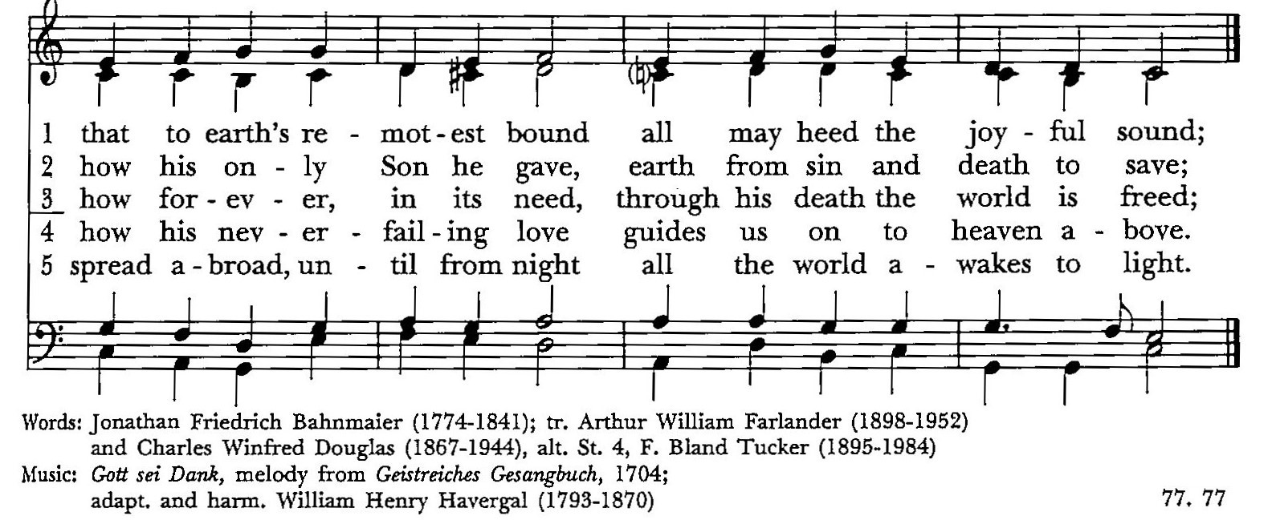

Dismissal

Go in peace to love and serve the Lord. Alleluia! Alleluia!
Thanks be to God. Alleluia! Alleluia!

Reminder: During the COVID shut-down, we will be live streaming our 10:00 am service. You can watch it on our website at www.stgabriels.church or on our Facebook page.

