**March 7, 2021**

**Third Sunday in Lent**



**10:00am – Rite II**

**St. Gabriel’s Episcopal Church**

**414 Pine St., Titusville, FL 32796**

[**www.stgabriels.church**](http://www.stgabriels.church)

**321-267-2545**

**Church Leadership**

**HEAD**

Jesus Christ

**BISHOP**

The Right Rev. Gregory O. Brewer

**WORSHIP TEAM**

The Rev. Dr. Margaret Callender Davis: Interim Pastor

The Rev. Dr. Ken Nolen: Associate Priest

Vergers: Vaughan Kimberling; Jenni Hill; Ellie Crockett

Andrew Smith: Organist (7:30)

Chris Moore: Organist (10:00)

David Herzog: Choir Director (10:00)

**VESTRY**

Edwin Hill: Senior Warden (321) 292-0727

Ron Rowton: Junior Warden (321) 591-7220

Lisa Barber * Jim Robey * Barbara Carter * Polly Schuster * Marion Hughes

Vaughan Kimberling, Clerk * Richard Cota, Treasurer * Dr. Al Koller, Vestry Advisor

**The Forge -** Katie Morrison (321) 412-7706 or godrocks5182@hotmail.com

**______________________________________________________________**

**Sunday Services**

**7:30 am – Rite I** (In person, mask required) and

**10:00 am – Rite II**

(In person, mask required & live streamed on Facebook)

**Emergency Pastoral Needs:**

Pastor Peg Davis (727) 773-5977

Father Ken Nolen (831) 235-9827

**The Great Litany**

*Please kneel or sit as you are able*

O God the Father, Creator of heaven and earth,  
***Have mercy upon us.***   
  
O God the Son, Redeemer of the world,  
***Have mercy upon us.***  
O God the Holy Ghost, Sanctifier of the faithful,  
***Have mercy upon us.***  
O holy, blessed, and glorious Trinity, one God,  
***Have mercy upon us.***  
Remember not, Lord Christ, our offenses, nor the offenses of our forefathers; neither reward us according to our sins. Spare us, good Lord, spare thy people, whom thou hast redeemed with thy most precious blood, and by thy mercy preserve us, for ever.  
***Spare us, good Lord.***

From all evil and wickedness; from sin; from the crafts and assaults of the devil; and from everlasting damnation,  
***Good Lord, deliver us.***

From all blindness of heart; from pride, vainglory, and hypocrisy; from envy, hatred, and malice; and from all want of charity,  
***Good Lord, deliver us.***

From all inordinate and sinful affections; and from all the deceits of the world, the flesh, and the devil,  
***Good Lord, deliver us.***

From all false doctrine, heresy, and schism; from hardness of heart, and contempt of thy Word and commandment,  
***Good Lord, deliver us.***

From lightning and tempest; from earthquake, fire, and flood; from plague, pestilence, and famine,  
***Good Lord, deliver us.***

From all oppression, conspiracy, and rebellion; from violence, battle, and murder; and from dying suddenly and unprepared,  
***Good Lord, deliver us.***

By the mystery of thy holy Incarnation; by thy holy Nativity and submission to the Law; by thy Baptism, Fasting, and Temptation,  
***Good Lord, deliver us.***

By thine Agony and Bloody Sweat; by thy Cross and Passion; by thy precious Death and Burial; by thy glorious Resurrection and Ascension; and by the Coming of the Holy Ghost,  
***Good Lord, deliver us.***

In all time of our tribulation; in all time of our prosperity; in the hour of death, and in the day of judgment,  
***Good Lord, deliver us.***

We sinners do beseech thee to hear us, O Lord God; and that it may please thee to rule and govern thy holy Church Universal in the right way,  
***We beseech thee to hear us, good Lord.***

That it may please thee to illumine all bishops, priests, and deacons, with true knowledge and understanding of thy Word; and that both by their preaching and living, they may set it forth, and show it accordingly,  
***We beseech thee to hear us, good Lord.***

That it may please thee to bless and keep all thy people,  
***We beseech thee to hear us, good Lord.***

That it may please thee to send forth laborers into thy harvest, and to draw all mankind into thy kingdom,  
***We beseech thee to hear us, good Lord.***

That it may please thee to give to all people increase of grace to hear and receive thy Word, and to bring forth the fruits of  
the Spirit,  
***We beseech thee to hear us, good Lord.***

That it may please thee to bring into the way of truth all such as have erred, and are deceived,  
***We beseech thee to hear us, good Lord.***

That it may please thee to give us a heart to love and fear thee, and diligently to live after thy commandments,  
***We beseech thee to hear us, good Lord.***

That it may please thee so to rule the hearts of thy servants, the President of the United States, and all others in authority, that they may do justice, and love mercy, and walk in the ways of truth,  
***We beseech thee to hear us, good Lord.***

That it may please thee to make wars to cease in all the world; to give to all nations unity, peace, and concord; and to bestow freedom upon all peoples,   
***We beseech thee to hear us, good Lord.***

That it may please thee to show thy pity upon all prisoners and captives, the homeless and the hungry, and all who are desolate and oppressed,  
***We beseech thee to hear us, good Lord.***

That it may please thee to give and preserve to our use the bountiful fruits of the earth, so that in due time all may enjoy them,  
***We beseech thee to hear us, good Lord.***

That it may please thee to inspire us, in our several callings, to do the work which thou givest us to do with singleness of heart as thy servants, and for the common good,  
***We beseech thee to hear us, good Lord.***

That it may please thee to preserve all who are in danger by reason of their labor or their travel,  
***We beseech thee to hear us, good Lord.***

That it may please thee to preserve, and provide for, all women in childbirth, young children and orphans, the widowed, and all whose homes are broken or torn by strife,  
***We beseech thee to hear us, good Lord.***

That it may please thee to visit the lonely; to strengthen all who suffer in mind, body, and spirit; and to comfort with thy presence those who are failing and infirm.  
***We beseech thee to hear us, good Lord.***

That it may please thee to support, help, and comfort all who are in danger, necessity, and tribulation,  
***We beseech thee to hear us, good Lord.***

That it may please thee to have mercy upon all mankind

***We beseech thee to hear us, good Lord.***

That it may please thee to give us true repentance; to forgive us all our sins, negligences, and ignorances; and to endue us with the grace of thy Holy Spirit to amend our lives according to thy holy Word,  
***We beseech thee to hear us, good Lord.***

That it may please thee to forgive our enemies, persecutors, and slanderers, and to turn their hearts,  
***We beseech thee to hear us, good Lord.***

That it may please thee to strengthen such as do stand; to comfort and help the weak-hearted; to raise up those who fall; and finally to beat down Satan under our feet,  
***We beseech thee to hear us, good Lord.***

That it may please thee to grant to all the faithful departed, eternal life and peace,  
***We beseech thee to hear us, good Lord.***

That it may please thee to grant that, in the fellowship of all the saints, we may attain to thy heavenly kingdom,  
***We beseech thee to hear us, good Lord.***

Today, we pray for the parishes of Trinity Church, Vero Beach and Church of the Messiah, Winter Garden.

We pray for all refugees in our communities and in the world.

As we search for our new rector, let us all pray

**Almighty God, who desires better things for your people than we can ask or imagine, prepare the heart of the one whom you have already chosen to be our priest. Guide us in our desire to discern your will for us through Him, who is our Head, Jesus Christ, our Lord.**  ***Amen***.

Please join me for a special prayer during this pandemic.

**Lord Jesus Christ, our Divine Physician, we ask you to guard and protect us from COVID-19 and from all serious illness.  For all that have died from it, have mercy; for those who are ill now, bring healing.  For those who are searching for a remedy, enlighten them; for medical caregivers helping the sick, strengthen and shield them.  By your grace, may you remove the evil of disease, and replace it with consolation and hope.  We abandon ourselves to your infinite love and mercy.  *Amen.***

Son of God, we beseech thee to hear us.  
***Son of God, we beseech thee to hear us.***

O Lamb of God, that takest away the sins of the world,  
***Have mercy upon us.***

O Lamb of God, that takest away the sins of the world,  
***Have mercy upon us.***

O Lamb of God, that takest away the sins of the world,  
***Grant us thy peace.***

O Christ, hear us.  
***O Christ, hear us.***

Lord, have Mercy upon us

***Christ have mercy upon us***

Lord, have Mercy upon us

**The Collect**

The Lord be with you

***And with thy Spirit***

Let us Pray

Almighty God, you know that we have no power in ourselves to help ourselves: Keep us both outwardly in our bodies and inwardly in our souls, that we may be defended from all adversities which may happen to the body, and from all evil thoughts which may assault and hurt the soul; through Jesus Christ our Lord, who lives and reigns with you and the Holy Spirit, one God, for ever and ever. *Amen.*

**Old Testament**

**Exodus 20:1-17**

Then God spoke all these words:

I am the Lord your God, who brought you out of the land of Egypt, out of the house of slavery; you shall have no other gods before me.

You shall not make for yourself an idol, whether in the form of anything that is in heaven above, or that is on the earth beneath, or that is in the water under the earth. You shall not bow down to them or worship them; for I the Lord your God am a jealous God, punishing children for the iniquity of parents, to the third and the fourth generation of those who reject me, but showing steadfast love to the thousandth generation of those who love me and keep my commandments.

You shall not make wrongful use of the name of the Lord your God, for the Lord will not acquit anyone who misuses his name.

Remember the sabbath day, and keep it holy. For six days you shall labour and do all your work. But the seventh day is a sabbath to the Lord your God; you shall not do any work—you, your son or your daughter, your male or female slave, your livestock, or the alien resident in your towns. For in six days the Lord made heaven and earth, the sea, and all that is in them, but rested the seventh day; therefore the Lord blessed the sabbath day and consecrated it.

Honor your father and your mother, so that your days may be long in the land that the Lord your God is giving you.

You shall not murder.

You shall not commit adultery.

You shall not steal.

You shall not bear false witness against your neighbor.

You shall not covet your neighbor’s house; you shall not covet your neighbor’s wife, or male or female slave, or ox, or donkey, or anything that belongs to your neighbor.

The Word of the Lord.

***Thanks be to God***

**The Psalm**

**Psalm 19**

1 The heavens declare the glory of God, *  
and the firmament shows his handiwork.

2 One day tells its tale to another, *  
and one night imparts knowledge to another.

3 Although they have no words or language, *  
and their voices are not heard,

4 Their sound has gone out into all lands, *  
and their message to the ends of the world.

5 In the deep has he set a pavilion for the sun; *  
it comes forth like a bridegroom out of his chamber;  
it rejoices like a champion to run its course.

6 It goes forth from the uttermost edge of the heavens  
and runs about to the end of it again; *  
nothing is hidden from its burning heat.

7 The law of the Lord is perfect  
and revives the soul; *  
the testimony of the Lord is sure  
and gives wisdom to the innocent.

8 The statutes of the Lord are just  
and rejoice the heart; *  
the commandment of the Lord is clear  
and gives light to the eyes.

9 The fear of the Lord is clean  
and endures for ever; *  
the judgments of the Lord are true  
and righteous altogether.

10 More to be desired are they than gold,  
more than much fine gold, *  
sweeter far than honey,  
than honey in the comb.

11 By them also is your servant enlightened, *  
and in keeping them there is great reward.

12 Who can tell how often he offends? *  
cleanse me from my secret faults.

13 Above all, keep your servant from presumptuous sins;  
let them not get dominion over me; *  
then shall I be whole and sound,  
and innocent of a great offense.

14 Let the words of my mouth and the meditation of my  
heart be acceptable in your sight, *  
O Lord, my strength and my redeemer.

**The Epistle**

**1 Corinthians 1:18-25**

The message about the cross is foolishness to those who are perishing, but to us who are being saved it is the power of God. For it is written,

“I will destroy the wisdom of the wise,   
and the discernment of the discerning I will thwart.”

Where is the one who is wise? Where is the scribe? Where is the debater of this age? Has not God made foolish the wisdom of the world? For since, in the wisdom of God, the world did not know God through wisdom, God decided, through the foolishness of our proclamation, to save those who believe. For Jews demand signs and Greeks desire wisdom, but we proclaim Christ crucified, a stumbling block to Jews and foolishness to Gentiles, but to those who are the called, both Jews and Greeks, Christ the power of God and the wisdom of God. For God’s foolishness is wiser than human wisdom, and God’s weakness is stronger than human strength.

The Word of the Lord.

***Thanks be to God.***

**The Gradual /** *Hymn 685*

*(Verse 1 before the Gospel and Verse 2 after the Gospel)*

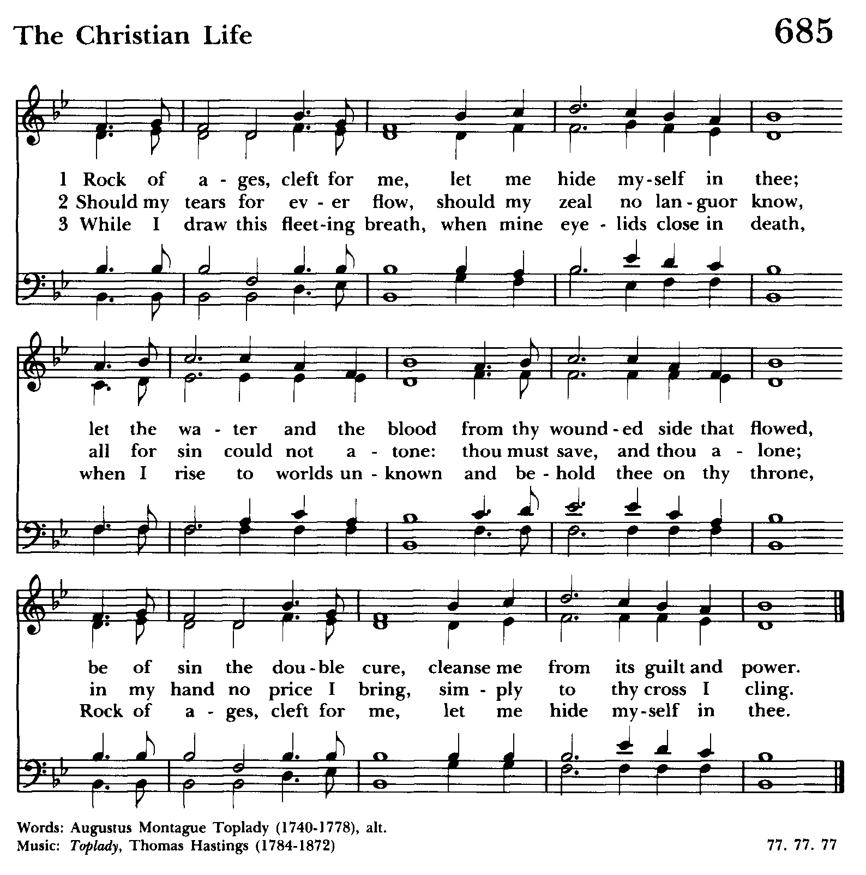

**The Gospel**

*Please stand*

The Holy Gospel of our Lord Jesus Christ according to **John 2:13**

***Glory be to thee, O Lord.***

The Passover of the Jews was near, and Jesus went up to Jerusalem. In the temple he found people selling cattle, sheep, and doves, and the money changers seated at their tables. Making a whip of cords, he drove all of them out of the temple, both the sheep and the cattle. He also poured out the coins of the money changers and overturned their tables. He told those who were selling the doves, “Take these things out of here! Stop making my Father’s house a marketplace!” His disciples remembered that it was written, “Zeal for your house will consume me.” The Jews then said to him, “What sign can you show us for doing this?” Jesus answered them, “Destroy this temple, and in three days I will raise it up.” The Jews then said, “This temple has been under construction for forty-six years, and will you raise it up in three days?” But he was speaking of the temple of his body. After he was raised from the dead, his disciples remembered that he had said this; and they believed the scripture and the word that Jesus had spoken.

The Gospel of the Lord.

***Praise be to thee, O Christ.***

**Sermon**

*Please stand and let us affirm our faith*

*in the words of the Nicene Creed together.*

**The Nicene Creed**

***We believe in one God,***

***the Father, the Almighty,***

***maker of heaven and earth,***

***of all that is, seen and unseen.***

***We believe in one Lord, Jesus Christ,***

***the only Son of God,***

***eternally begotten of the Father,***

***God from God, Light from Light,***

***true God from true God,  
    begotten, not made,***

***of one Being with the Father.***

***Through him all things were made.***

***For us and for our salvation***

***he came down from heaven:  
by the power of the Holy Spirit***

***he became incarnate from the Virgin Mary,  
     and was made man.***

***For our sake he was crucified under Pontius Pilate;***

***he suffered death and was buried.***

***On the third day he rose again***

***in accordance with the Scriptures;***

***he ascended into heaven***

***and is seated at the right hand of the Father.***

***He will come again in glory to judge the living and the dead,  
        and his kingdom will have no end.***

***We believe in the Holy Spirit, the Lord, the giver of life,   
    who proceeds from the Father and the Son.  
    With the Father and the Son he is worshiped and glorified.  
    He has spoken through the Prophets.  
    We believe in one holy catholic and apostolic Church.  
    We acknowledge one baptism for the forgiveness of sins.  
    We look for the resurrection of the dead,  
        and the life of the world to come. Amen.***

**The Peace**

The peace of the Lord be always with you.  
***And with thy spirit***

**Announcements & Special Blessings**

**For Birthdays:**

***O God, our times are in your hand: Look with favor, we pray, on your servant as he/she begins another year. Grant that he/she may grow in wisdom and grace, and strengthen his/her trust in your goodness all the days of his/her life; through Jesus Christ our Lord. Amen.***

**For Anniversaries:**

***O God, you have so consecrated the covenant of marriage that in it is represented the spiritual unity between Christ and his Church: Send therefore your blessing upon these your servants, that they may so love, honor, and cherish each other in faithfulness and patience, in wisdom and true godliness, that their home may be a haven of blessing and peace; through Jesus Christ our Lord, who lives and reigns with you and the Holy Spirit, one God, now and forever. Amen.***

**For Travelers:**

***O God, our heavenly Father, whose glory fills the whole creation, and whose presence we find wherever we go: Preserve those who travel; surround them with your loving care; protect them from every danger; and bring them in safety to their journey’s end; through Jesus Christ our Lord. Amen.***

**THE HOLY COMMUNION**

**The Offertory Sentence**

Walk in love, as Christ loves us, and gave himself for us: an offering and a sacrifice to God.

**The Offertory Hymn** (Please stand)

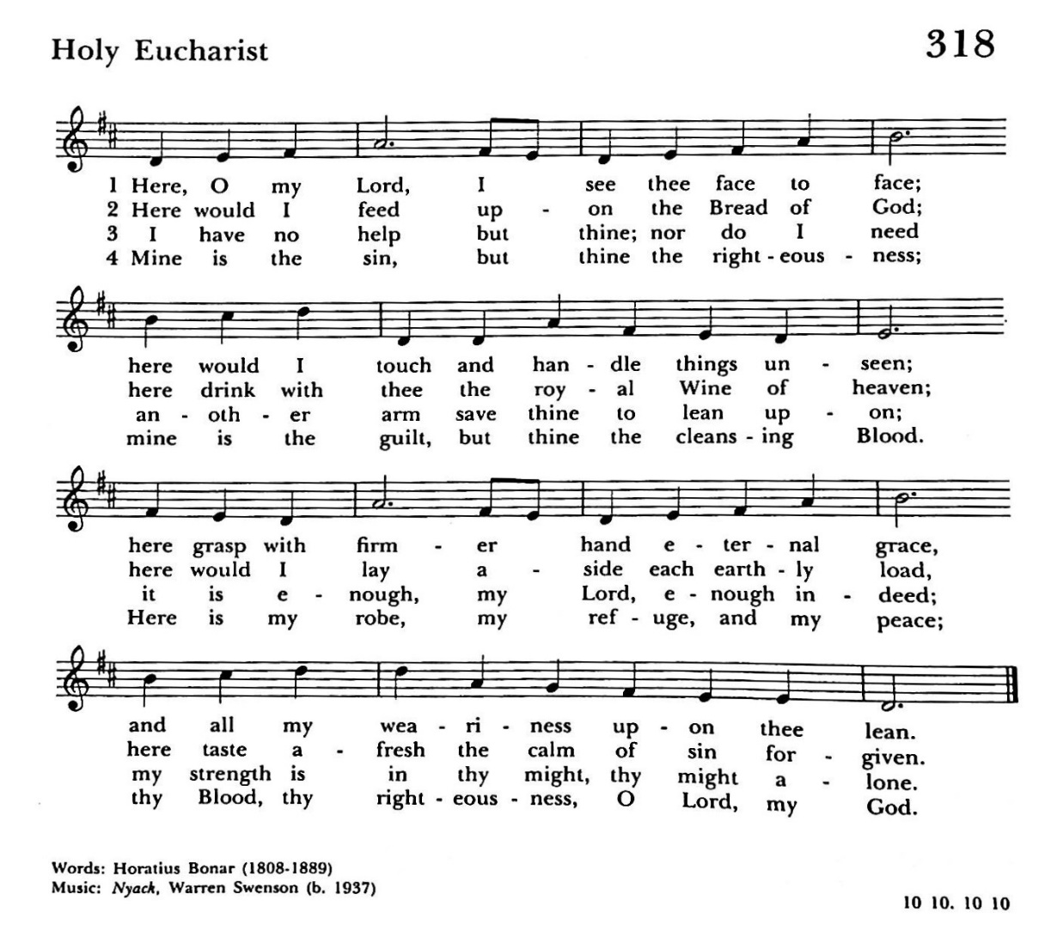

**The Great Thanksgiving**

The Lord be with you.  
***And also with you.***Lift up your hearts.  
***We lift them to the Lord.***Let us give thanks to the Lord our God.  
***It is right to give him thanks and praise.***

It is right, and a good and joyful thing, always and everywhere to give thanks to you, Father Almighty, Creator of heaven and earth, through Jesus Christ our Lord; who was tempted in every way as we are, yet did not sin. By his grace we are able to triumph over every evil, and to live no longer for ourselves alone, but for him who died for us and rose again.

Therefore we praise you, joining our voices with Angels and Archangels and with all the company of heaven, who forever sing this hymn to proclaim the glory of your Name:

**The Sanctus S-122**

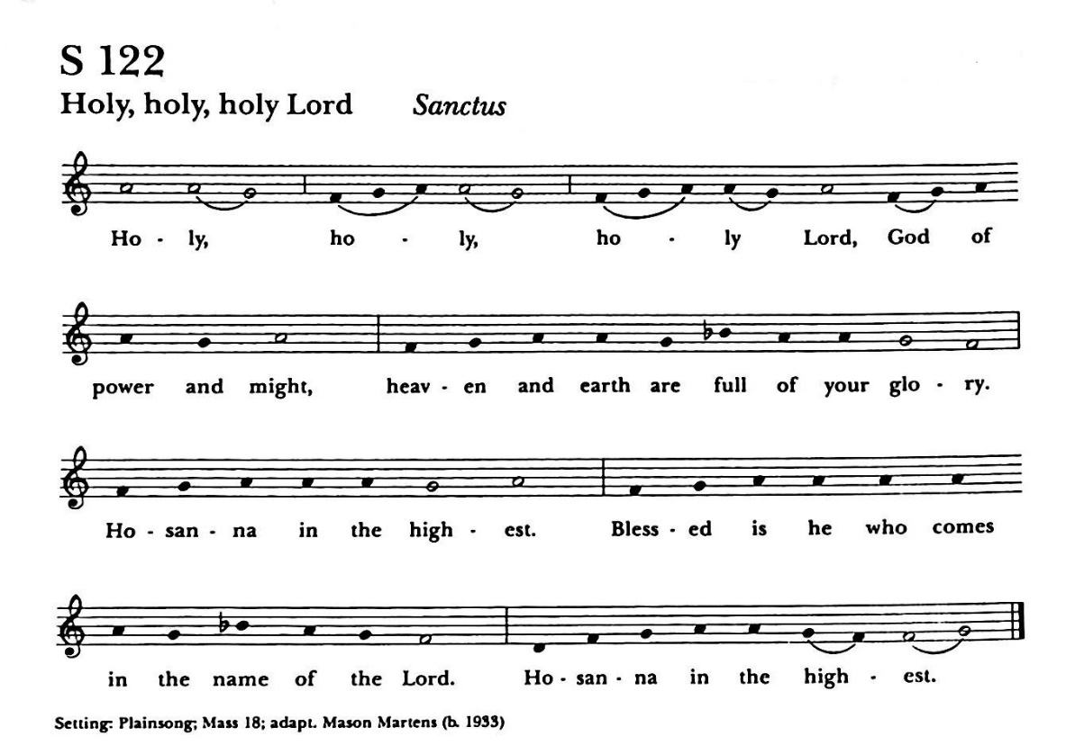

*Please Kneel or sit as you are able.*

Holy and gracious Father: In your infinite love you made us for yourself, and, when we had fallen into sin and become subject to evil and death, you, in your mercy, sent Jesus Christ, your only and eternal Son, to share our human   
nature, to live and die as one of us, to reconcile us to you, the God and Father of all.  
  
He stretched out his arms upon the cross, and offered himself, in obedience to your will, a perfect sacrifice for the whole world.

On the night before he died for us, our Lord Jesus Christ took bread; and when he had given thanks to you, he broke it, and gave it to his disciples, and said, "Take, eat: This is my Body**,** which is given for you. Do this for the remembrance of me."

After supper he took the cup of wine; and when he had given thanks, he gave it to them, and said, "Drink this, all of you: This is my Blood of the new Covenant, which is shed for you and for many for the forgiveness of sins. Whenever you drink it, do this for the remembrance of me."

Therefore we proclaim the mystery of faith:

***Christ has died.  
Christ is risen.  
Christ will come again.***

We celebrate the memorial of our redemption, O Father, in this sacrifice of praise and thanksgiving. Recalling his death, resurrection, and ascension, we offer you these gifts.  
  
Sanctify them by your Holy Spirit to be for your people the Body and Blood of your Son, the holy food and drink of new and unending life in him. Sanctify us also that we may faithfully receive this holy Sacrament, and serve you in unity, constancy, and peace; and at the last day bring us with all your saints   
into the joy of your eternal kingdom.  
  
All this we ask through your Son Jesus Christ: By him, and with him, and in him, in the unity of the Holy Spirit all honor and glory is yours, Almighty Father, now and for ever. AMEN.

**The Lord’s Prayer**

And now, as our Savior Christ has taught us,

we are bold to say,

***Our Father, who art in heaven,***

***hallowed be thy Name,***

***thy kingdom come,***

***thy will be done,***

***on earth as it is in heaven.***

***Give us this day our daily bread.***

***And forgive us our trespasses,***

***as we forgive those***

***who trespass against us.***

***And lead us not into temptation,***

***but deliver us from evil.***

***For thine is the kingdom,***

***and the power, and the glory,***

***for ever and ever. Amen.***

**The Breaking of the Bread**

*The priest breaks the bread*

Christ our Passover is sacrificed for us;

***Therefore let us keep the feast.***

**Fraction Anthem /** *Hymnal S-160*

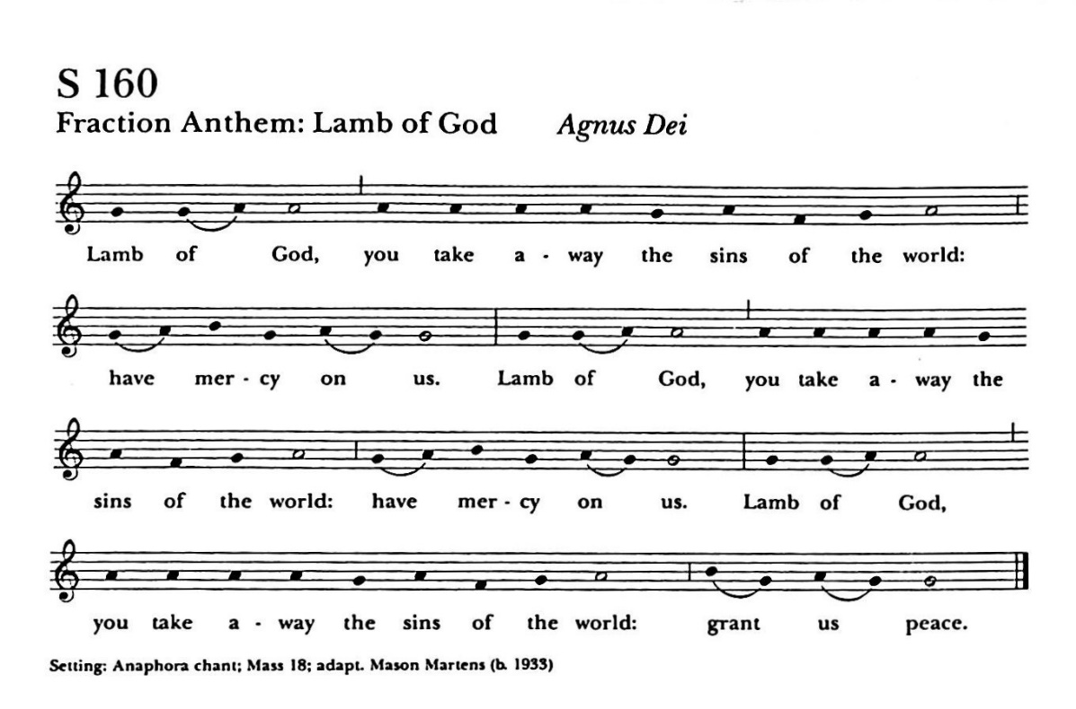

The Gifts of God for the People of God. Take them in remembrance that Christ died for you, and feed on him in your hearts by faith, with thanksgiving.

***Prayer of Intention***

*(for those viewing on-line)*

***In union, O Lord,***

***with your faithful people at every altar of your Church,***

***where the Holy Eucharist is now being celebrated,***

***I desire to offer to you praise and thanksgiving.***

***I remember your death, Lord Christ;***

***I proclaim your resurrection;***

***I await your coming in glory.***

***And since I cannot receive you today in the Sacrament***

***of your Body and Blood,***

***I beseech you to come spiritually into my heart.***

***Cleanse and strengthen me with your grace, Lord Jesus,***

***and let me never be separated from you.***

***May I live in you, and you in me, in this life and in the life to come.***

***Amen.***

*(distribution of communion)*

**The Post Communion Prayer**

Let us pray.

***Almighty and everliving God, we thank you for feeding us with the spiritual food of the most precious Body and Blood of your Son our Savior Jesus Christ; and for assuring us in these holy mysteries that we are living members of the Body of your Son, and heirs of your eternal kingdom. And now, Father, send us out to do the work you have given us to do, to love and serve you as faithful witnesses of Christ our Lord. To him, to you, and to the Holy Spirit, be honor and glory, now and for ever. Amen.***

**The Blessing**

**The Procession into the World /** *Hymn 703*

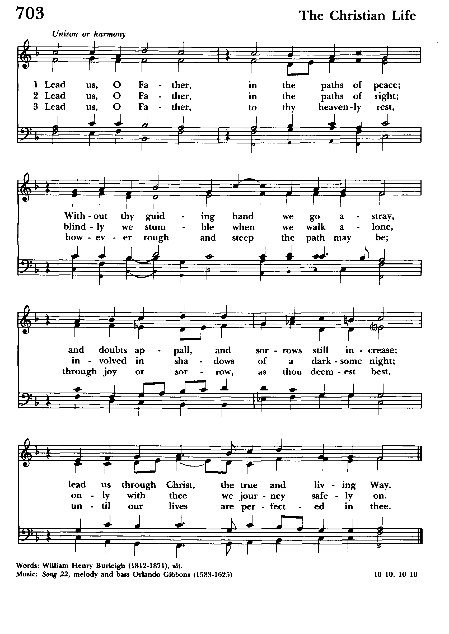

**The Dismissal**

Let us bless the Lord

***Thanks be to God.***

***Announcements***

Please call the church office at 321-267-2545

if you would like to have someone added to our prayer list.

**There is lessening of COVID restrictions we are**

**no longer requesting reservations.**

**Masks are still required!!**

**Saturday March 13th, 2021**

9:00am to 1:00pm - Via Zoom

*A Lenten Quiet Day for Women*

Sponsored by the St. Gabriel Chapter of

The Order of the Daughters of the King®

Presenters: Fr. Ken Nolen and Marie Hunsaker

If interested, please contact

Marie Hunsaker at (321) 362-0580

**Confirmation – Sunday March 14th**

Please pray for those preparing to receive the sacrament:

Jon & Lesli Mather, Nancy Lister, Mary & Dan Owens, Jane Ann Burnett, Robert Simms, and Jackson Bainbridge. Wilma Holman will be re-affirming her faith as well.

**News from our Rector Search Committee:**

**Search Committee Accepting Suggestions for Candidates**

Per the Diocese of Central Florida VACANCY and SEARCH PROCEDURES, the search committee requests suggestions from the congregation for clergy names to be submitted to the bishop for consideration as potential candidates for the open position of rector at St. Gabriel’s.

These names, with current contact information, should be submitted CONFIDENTIALITY to the chair of our Search Committee, Carol Seidel, for forwarding to Bishop Brewer. After review, the bishop may or may not return these names to the search committee as candidates we may consider for our vacancy.

If you know someone who would be interested, and whom, after prayerful consideration you believe would be a good fit, please place this information in a sealed envelope addressed to Carol Seidel, Search Committee Chair.

This sealed envelope can be brought  to church to be handed to Pastor Peg, Edwin Hill, or Carol Seidel, or can be mailed to the St. Gabriel’s church office, marked, “Attention: Search Committee Chair”.

Confidentially is essential, to protect the potential candidate and their relationship with the congregation they now serve.

It is anticipated that we will be accepting suggestions until Easter Sunday.